**Web Technology Project**

**Group members**:

1. Soumyo Subhro Mukhopadhyay (Roll No. : 14501219004)

2. Sambuddha Mondal (Roll No. : 14501219002)

3. Rohan Chakraborty (Roll No. : 14501219018)

4. Mou Dutta (Roll No. : 14501219067)

**Year**: 2nd year

**Semester**: 3

**Topic Name**: Online Shopping Website

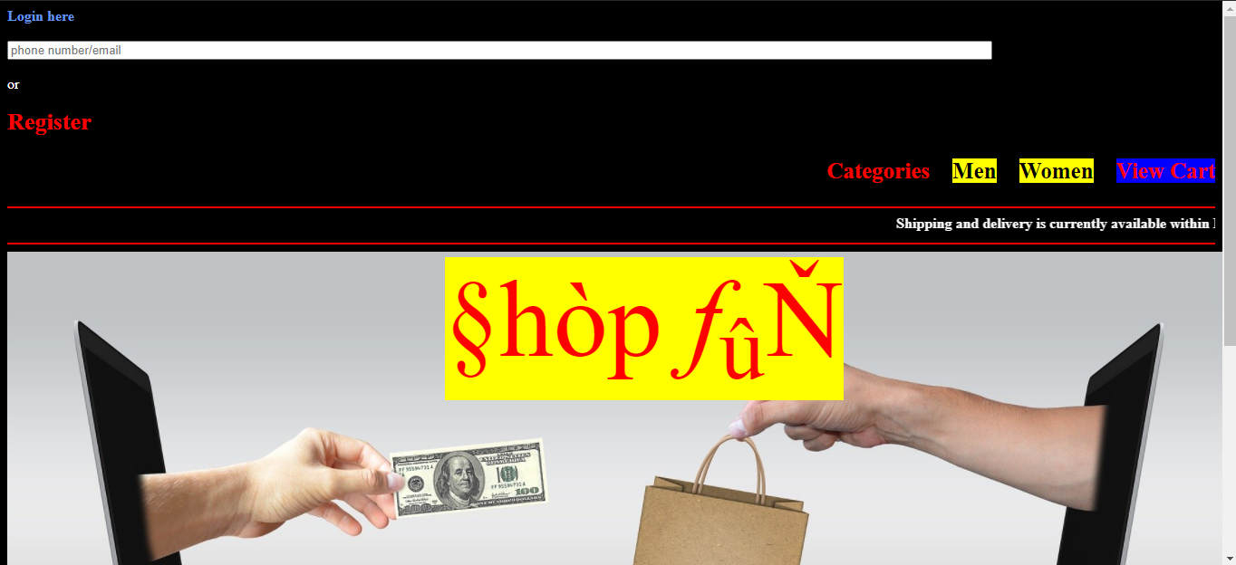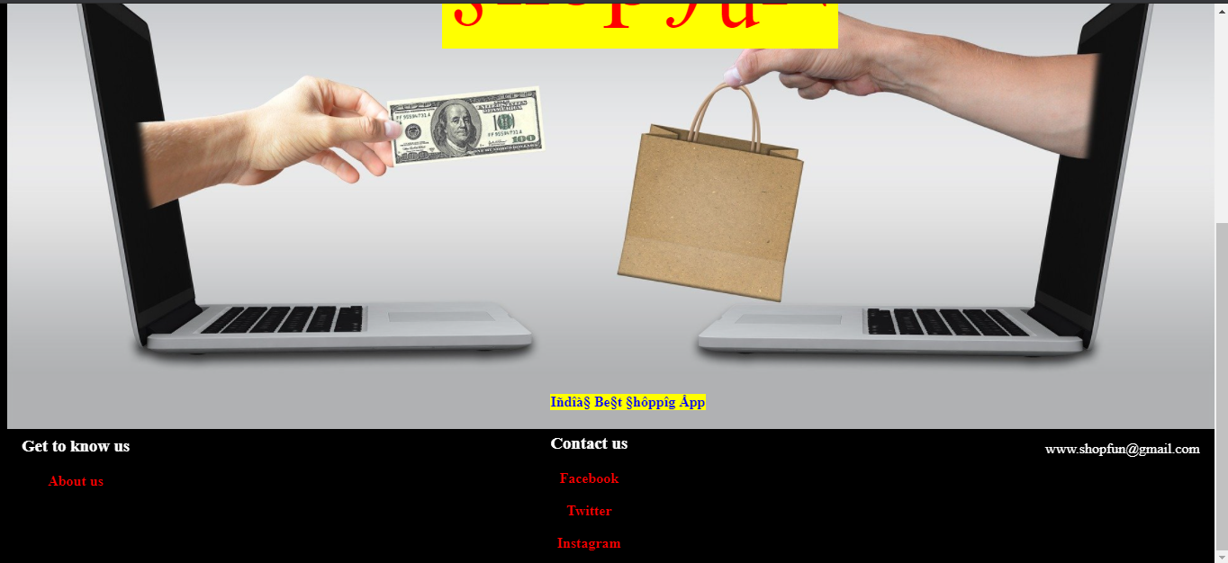

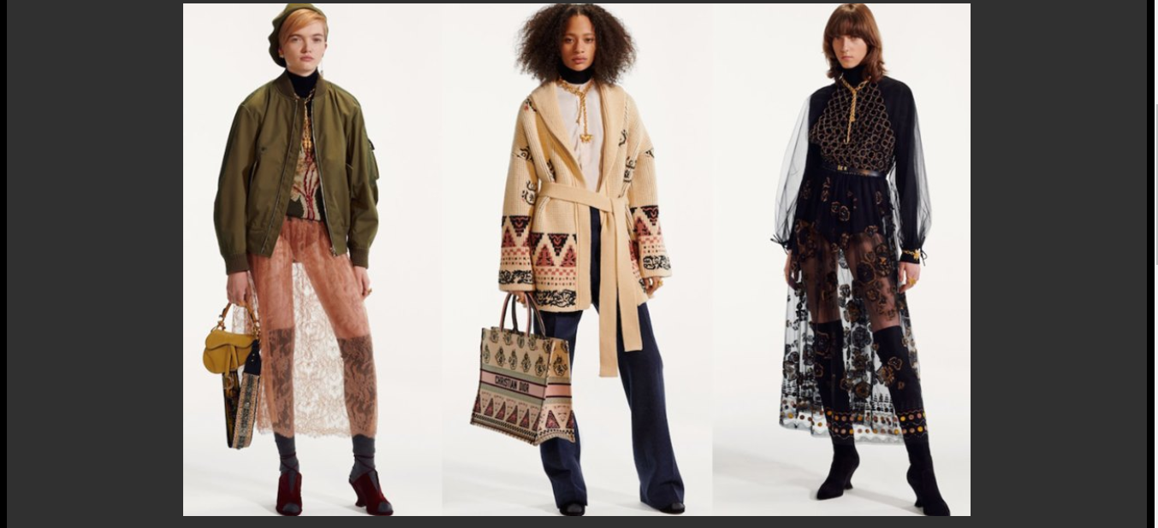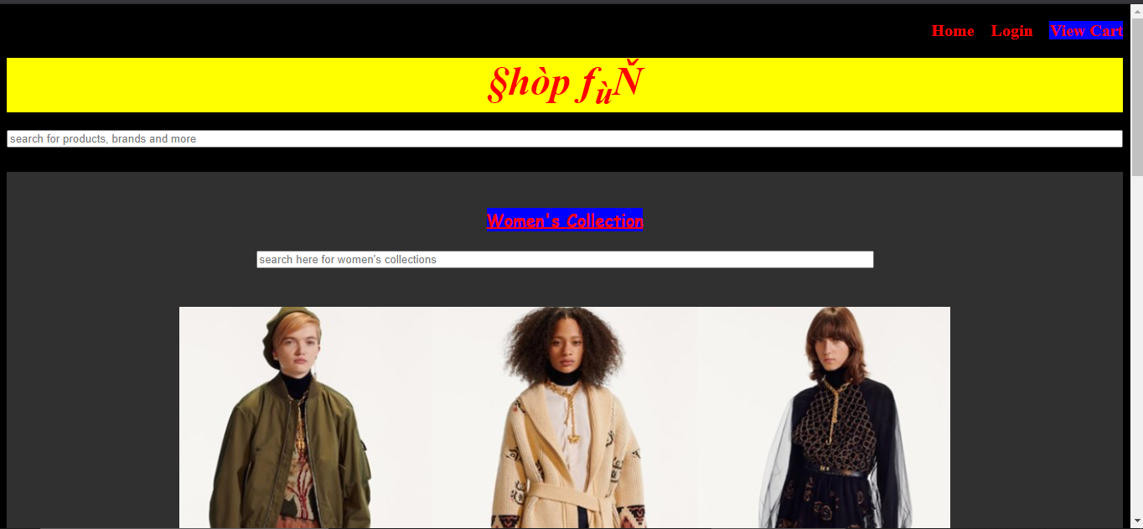

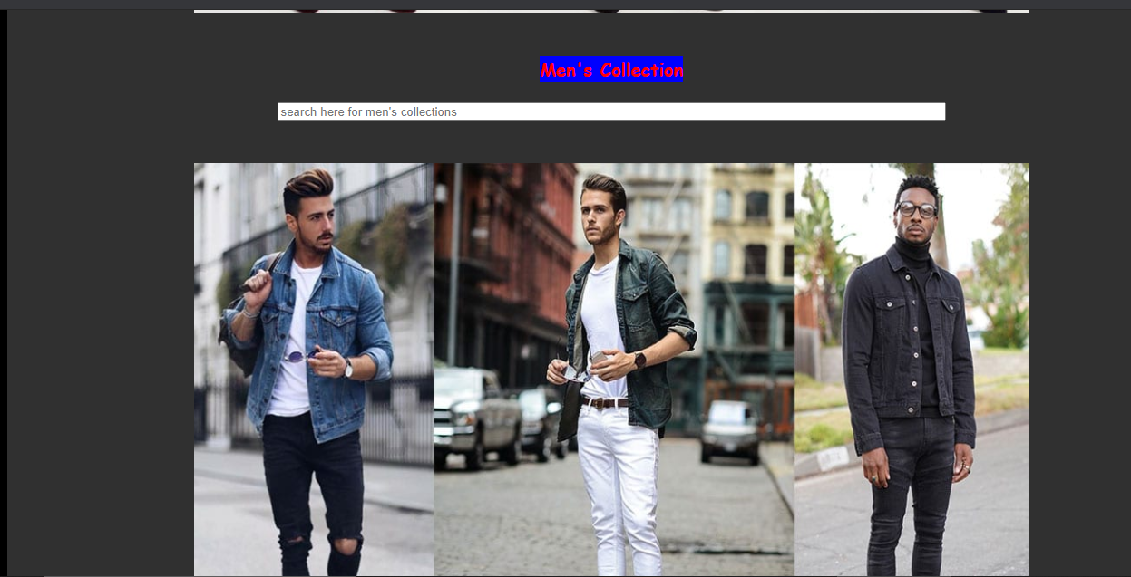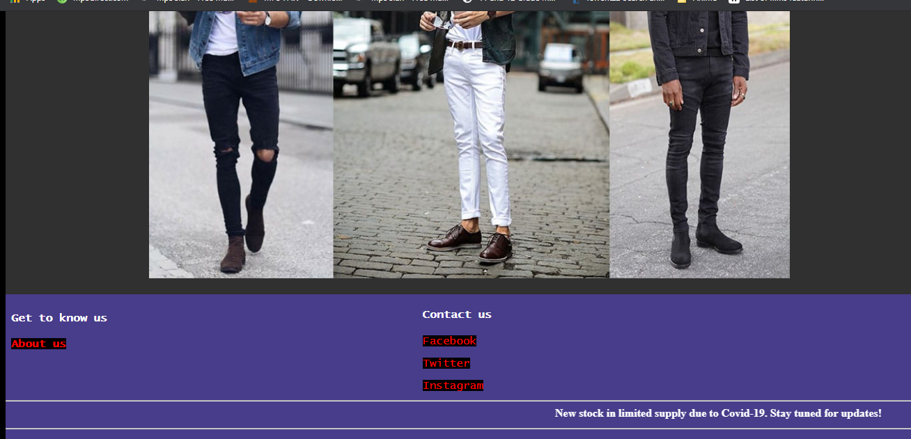

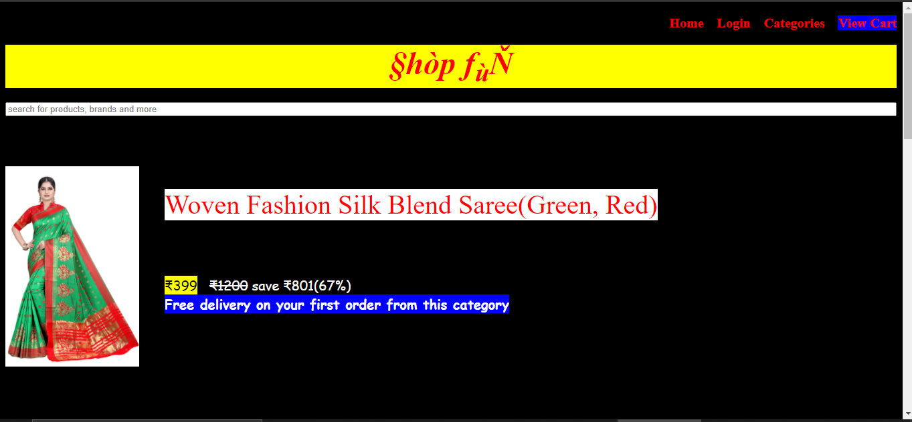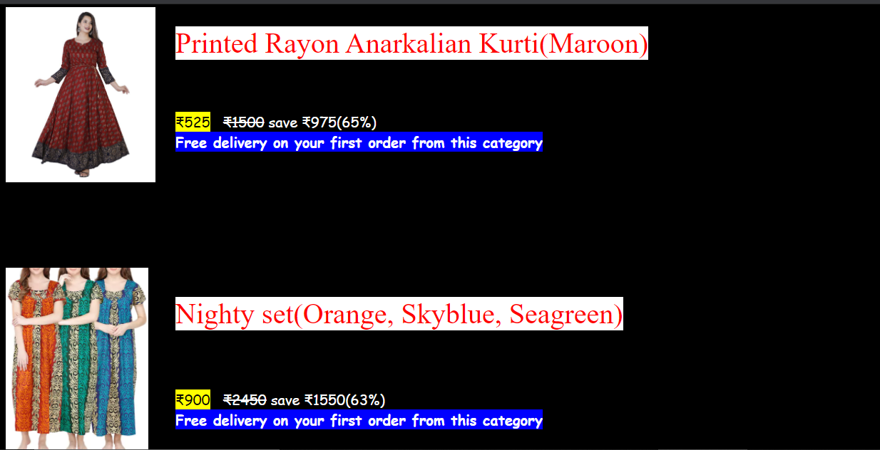

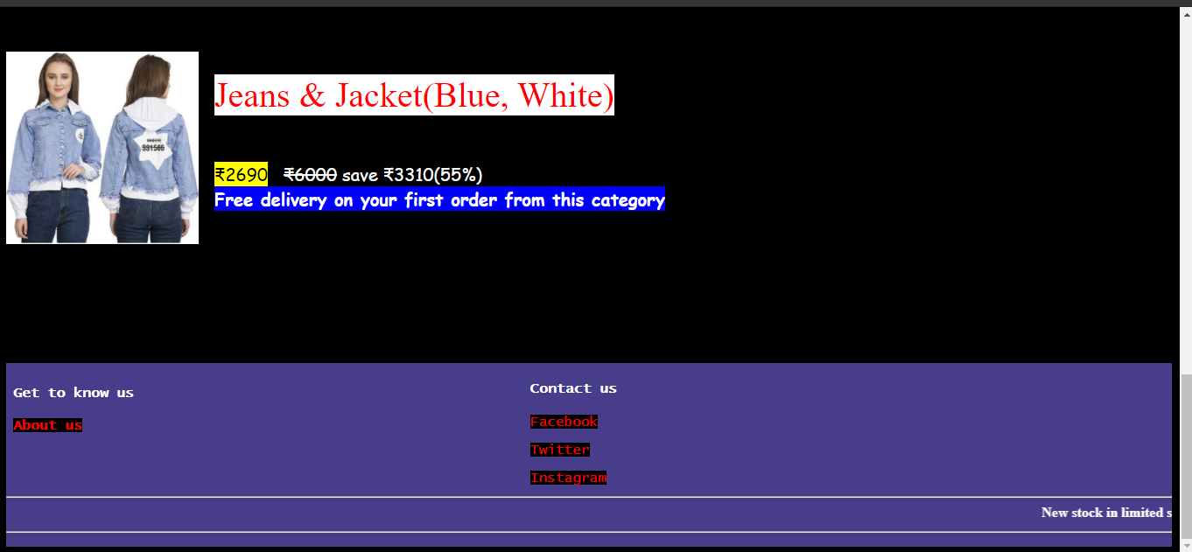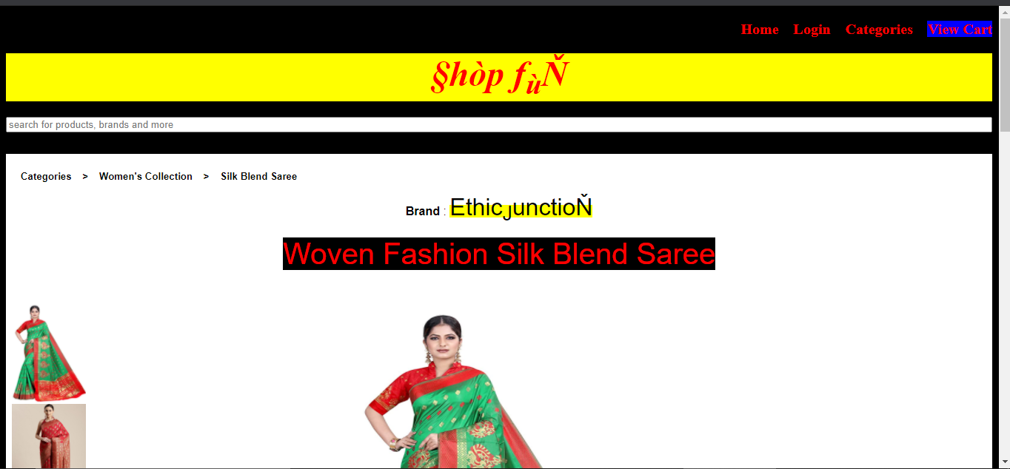

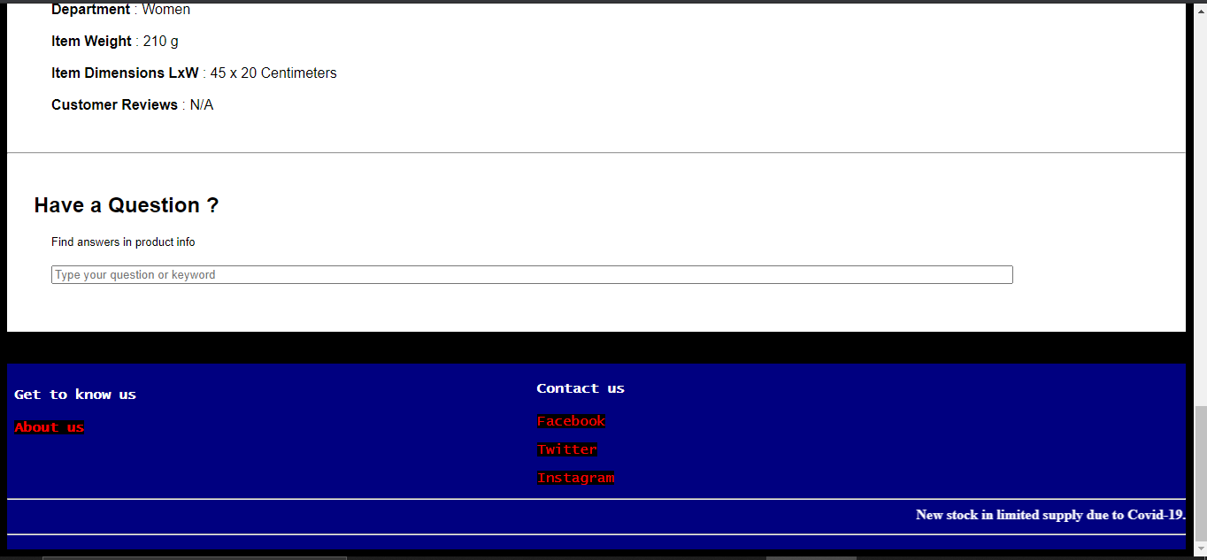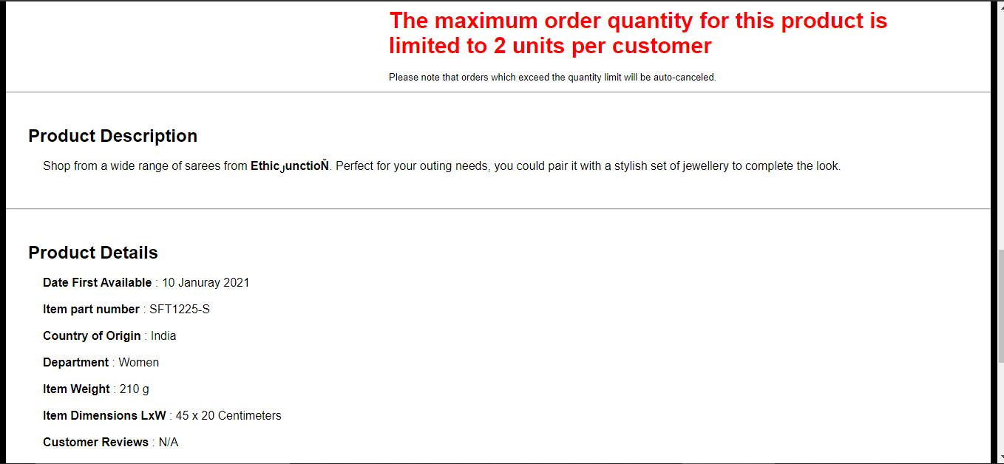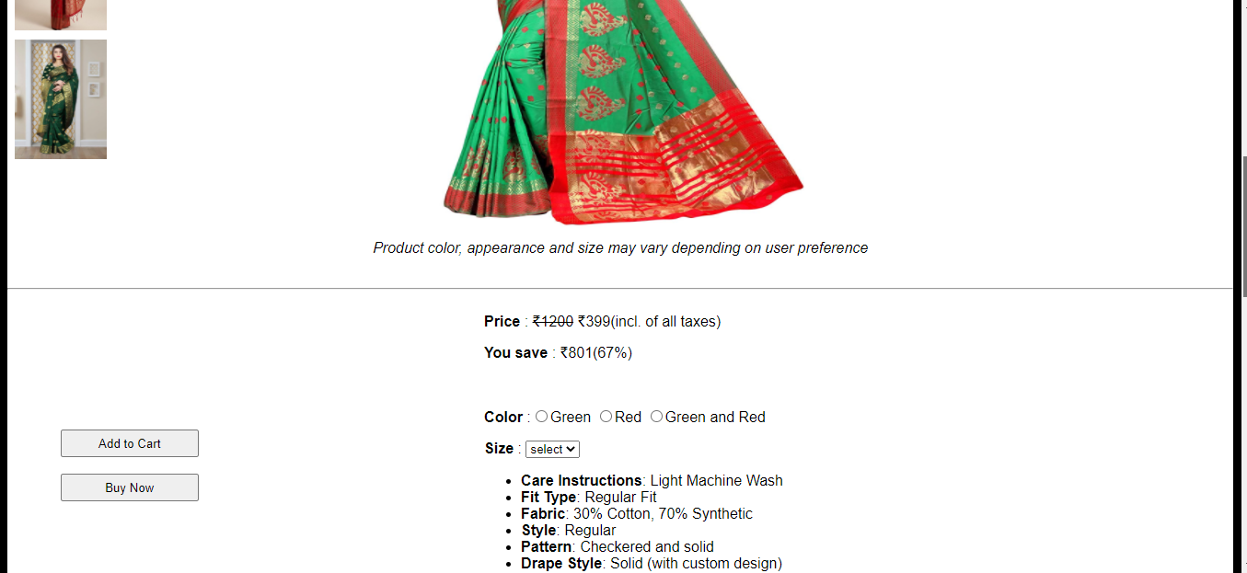

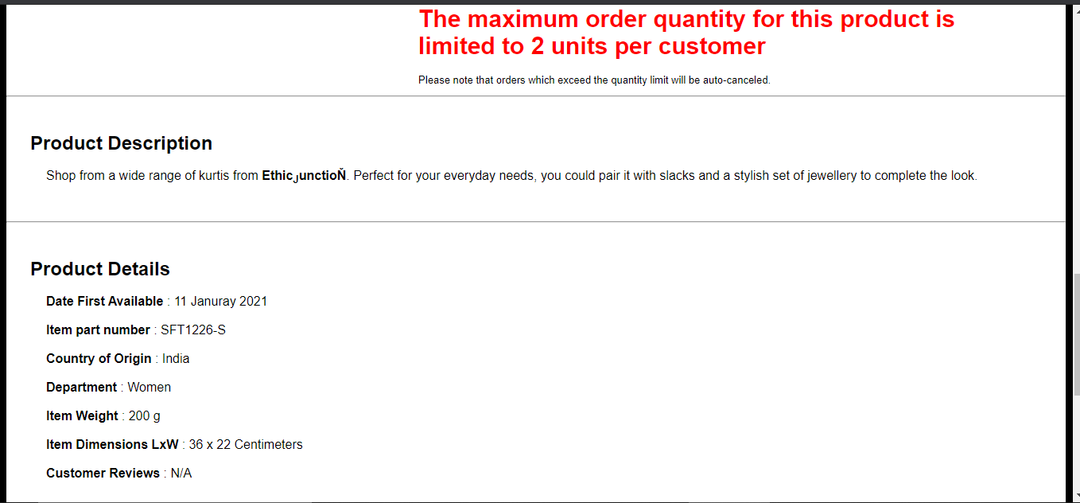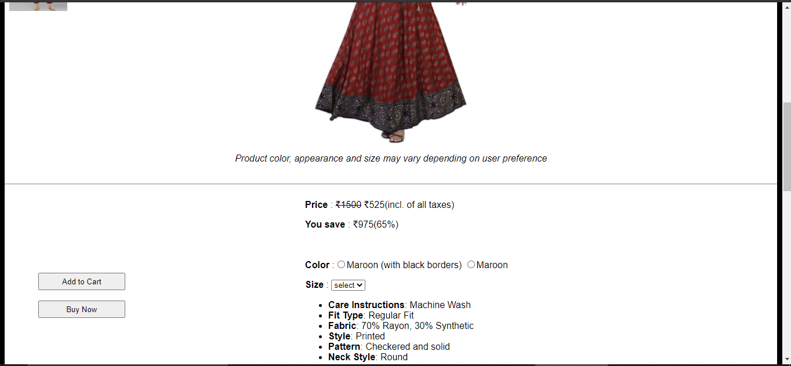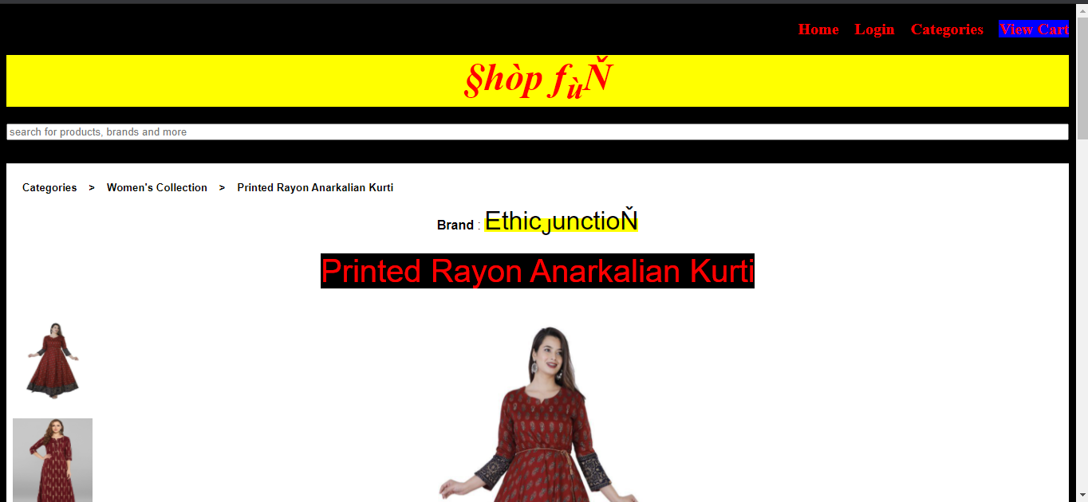

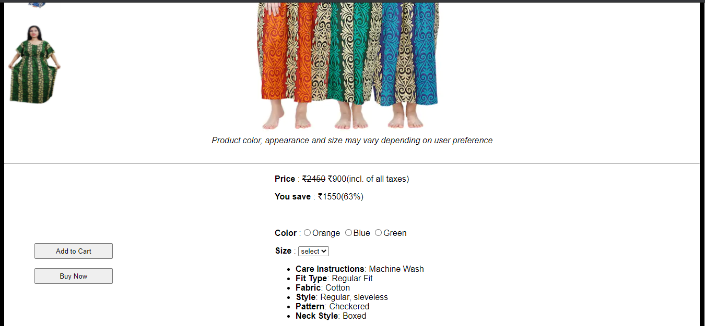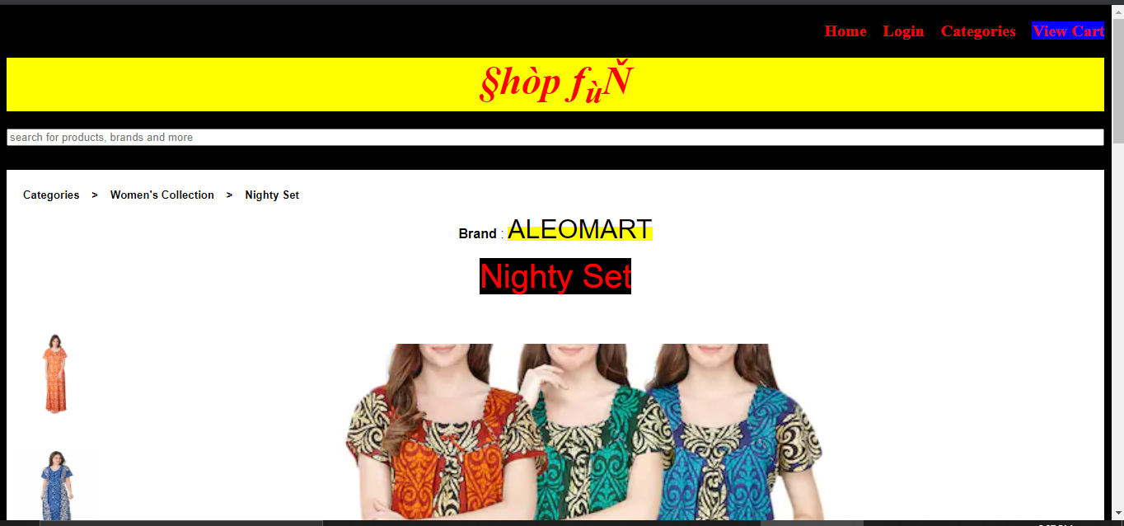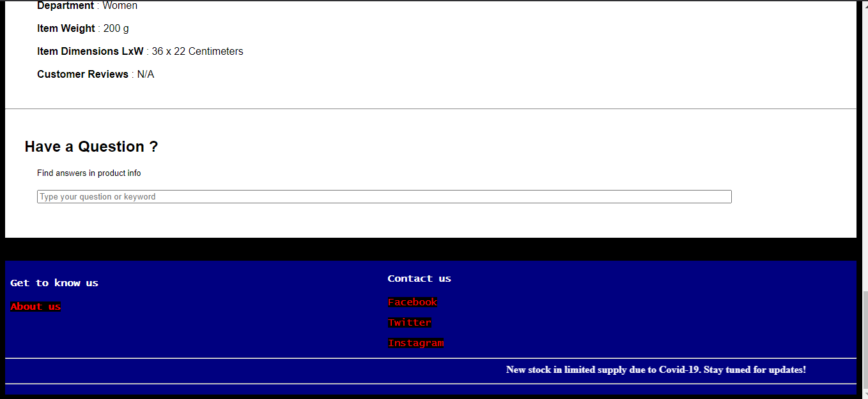

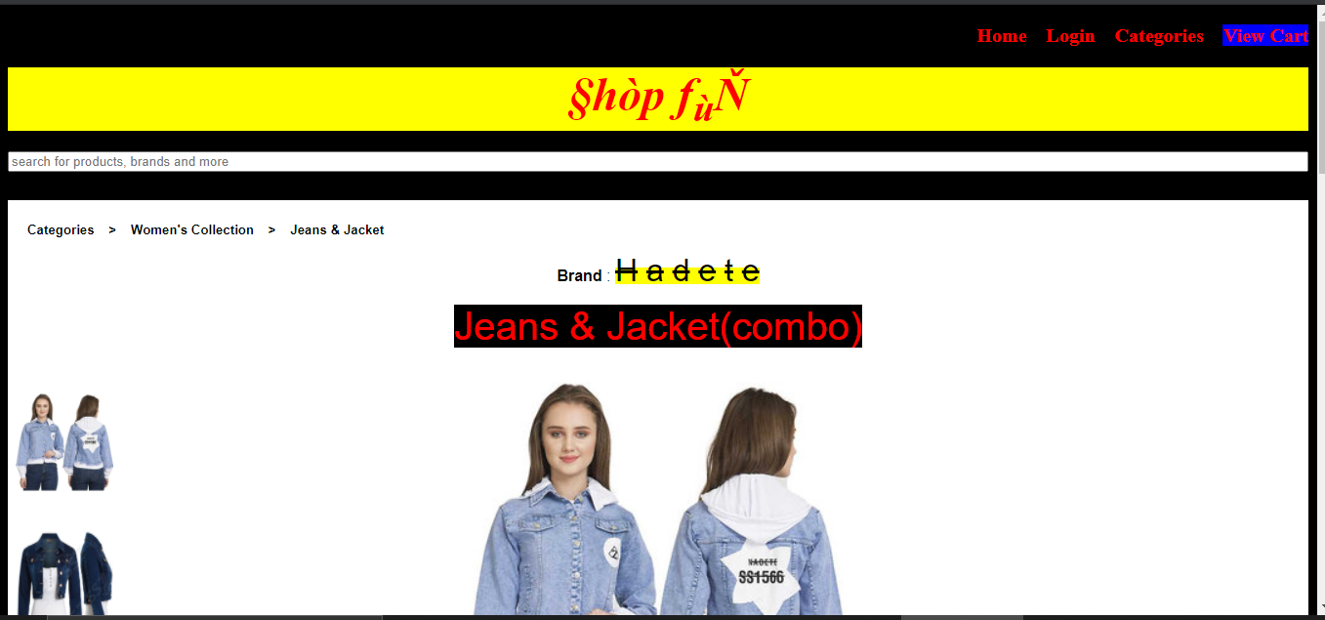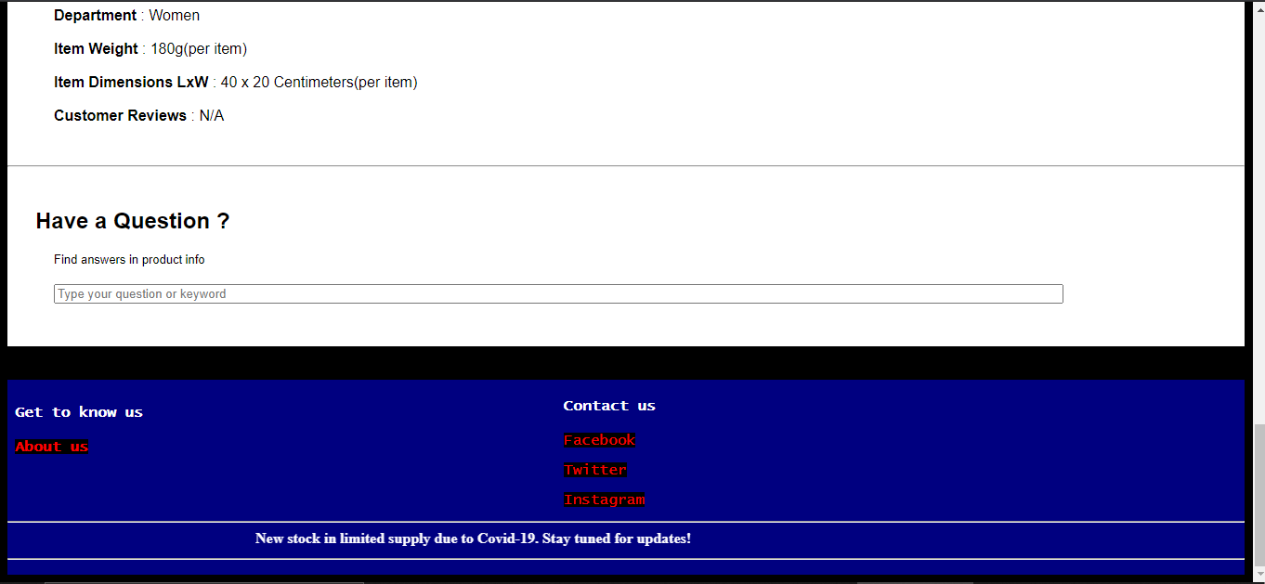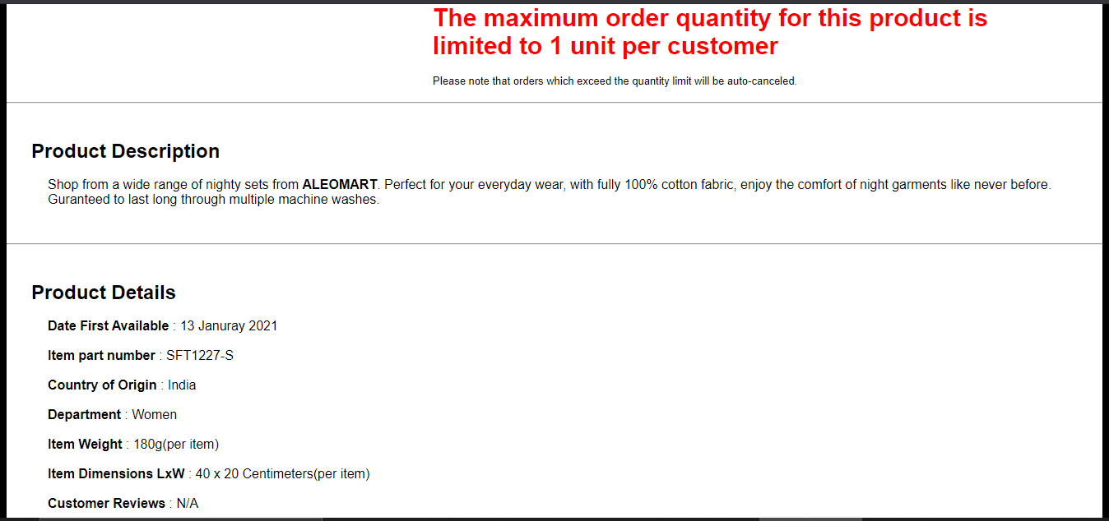

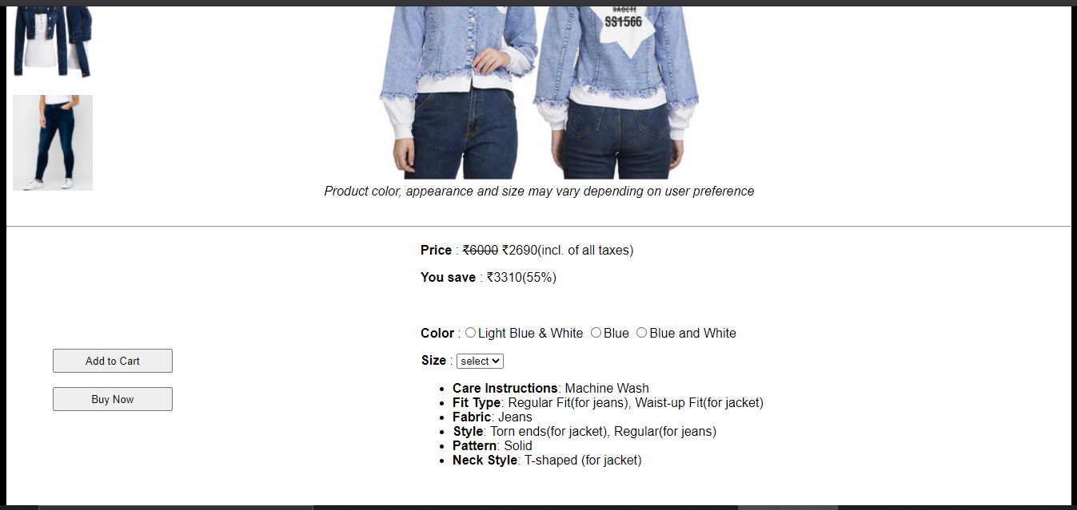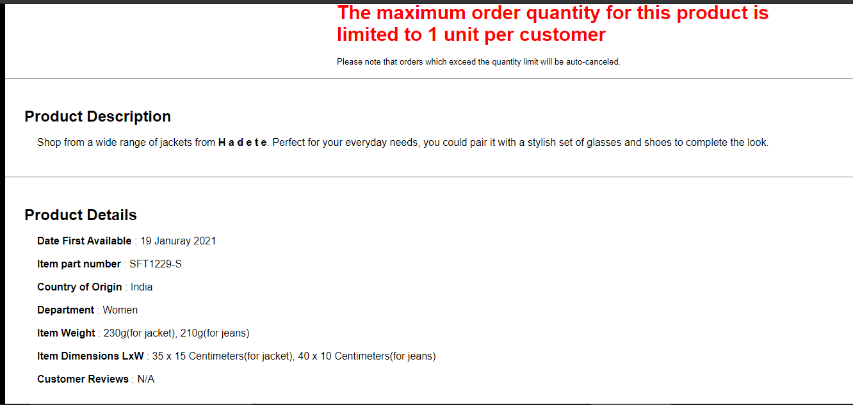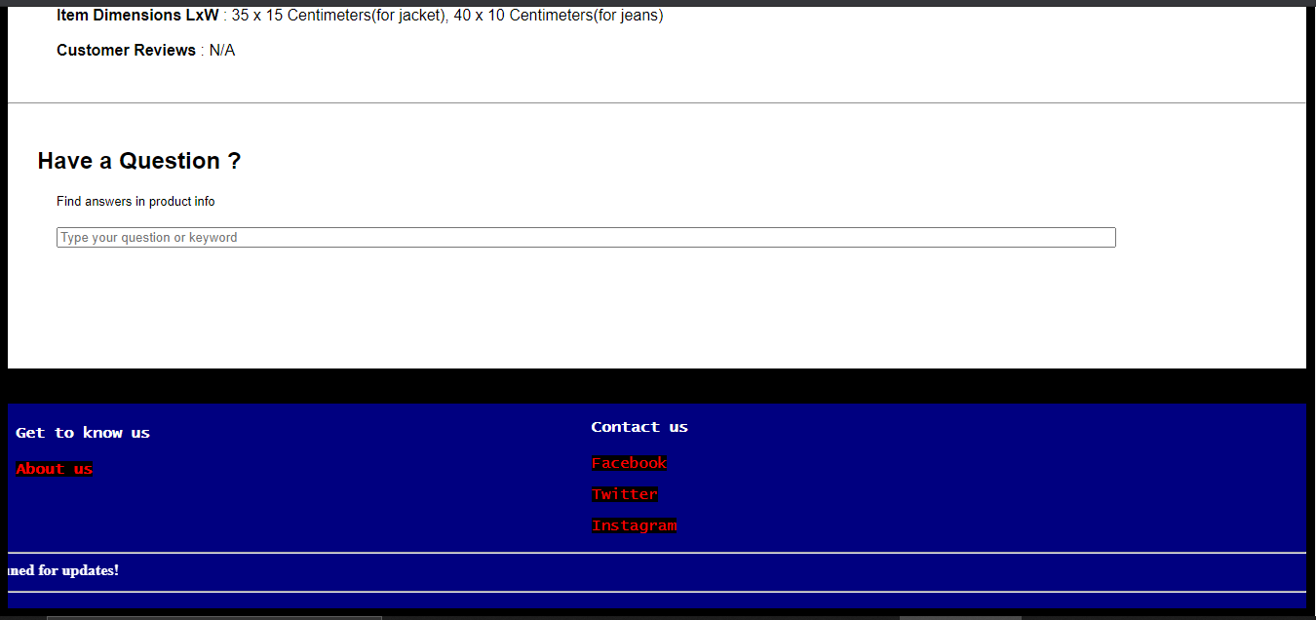

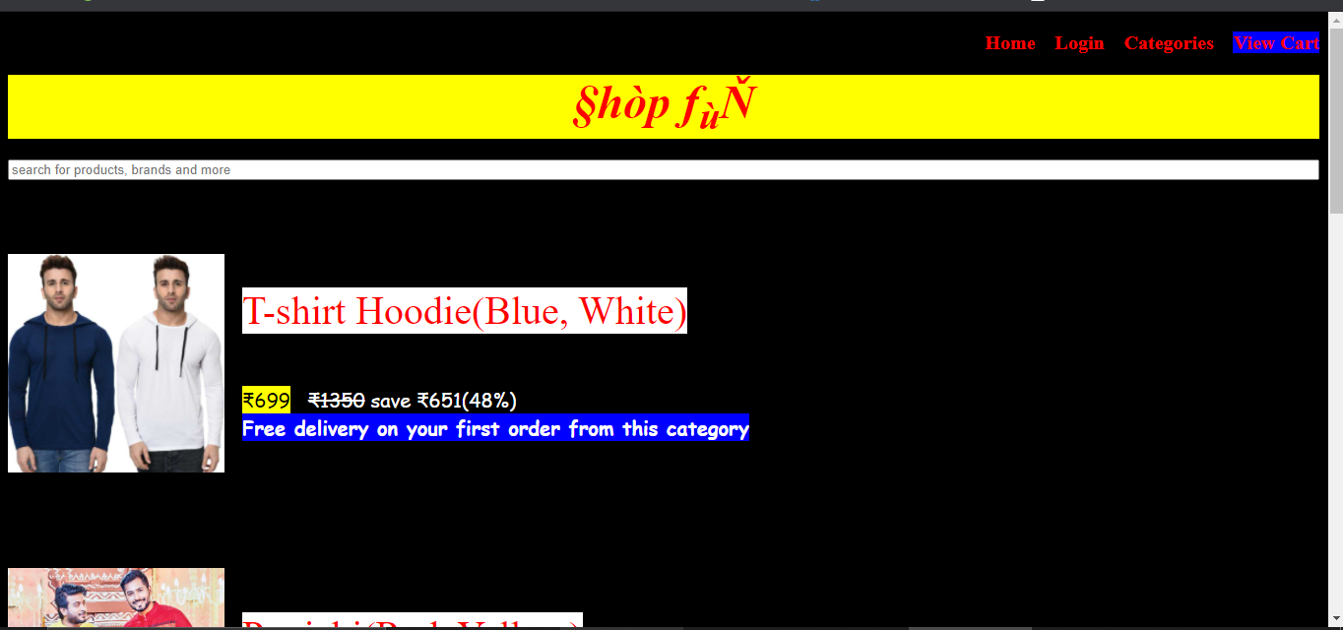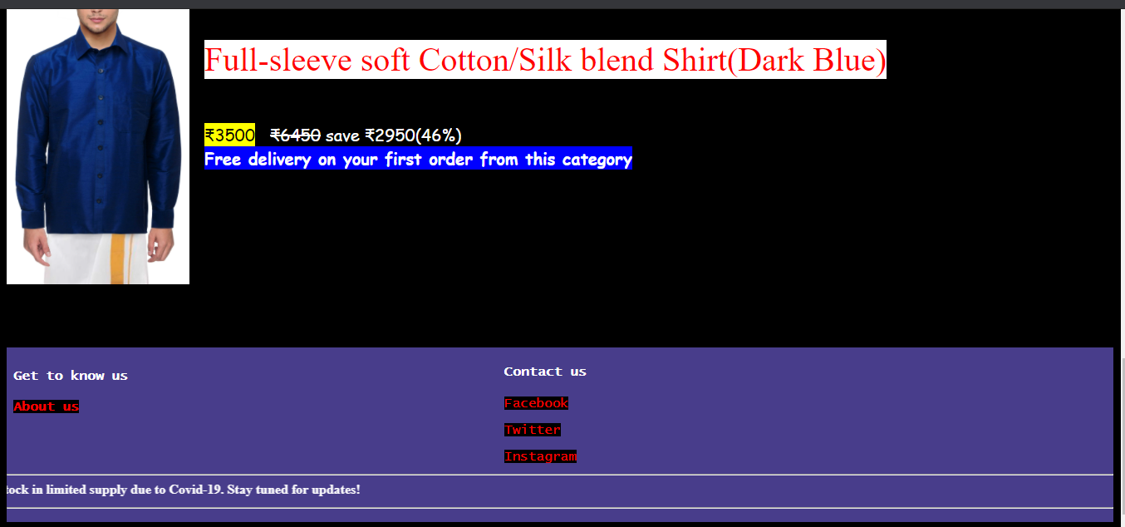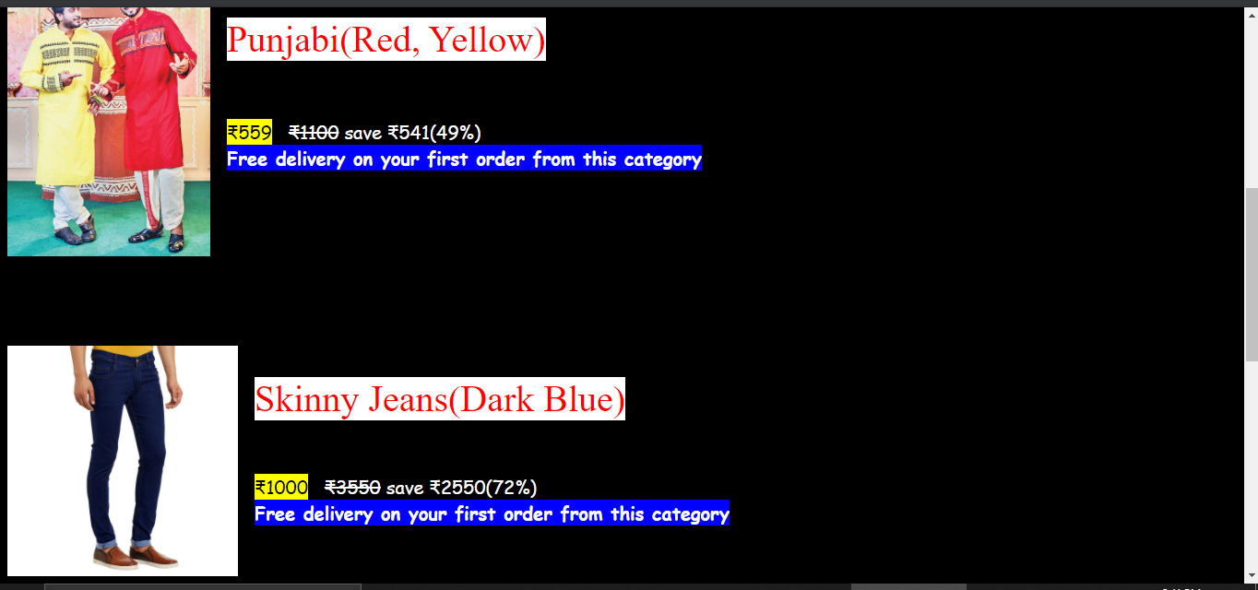

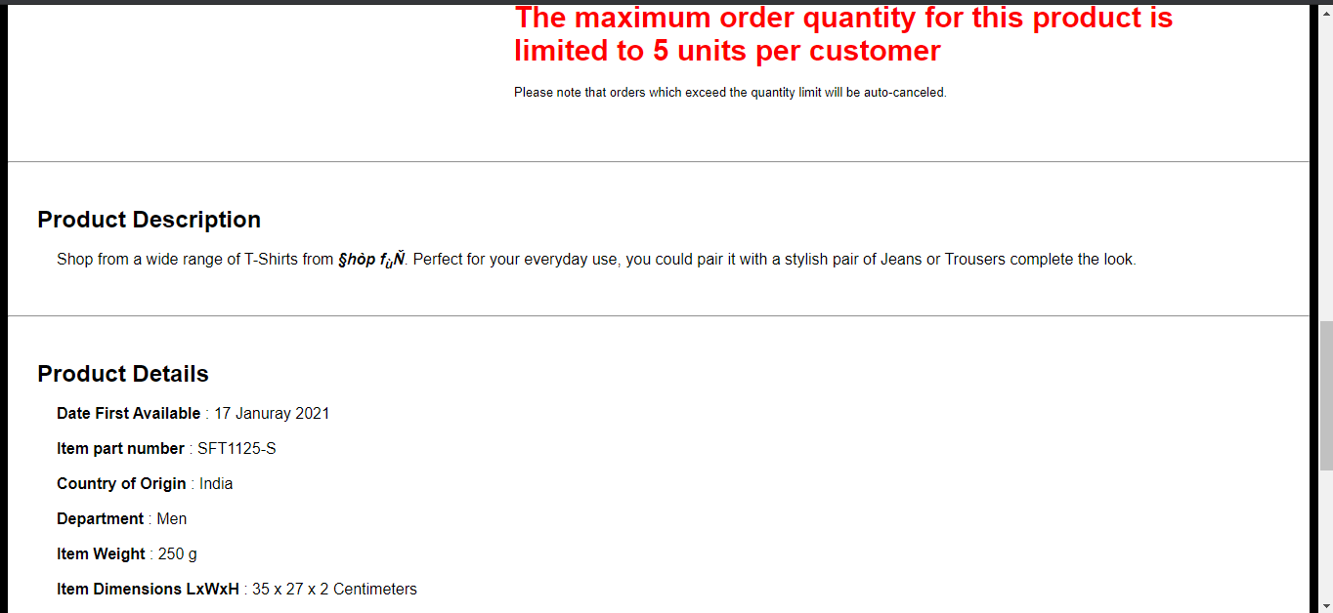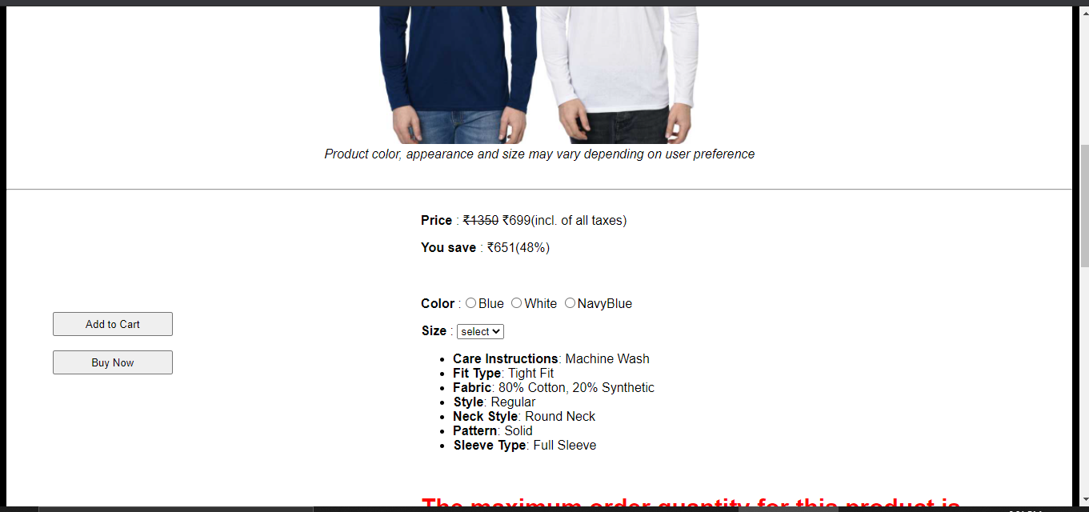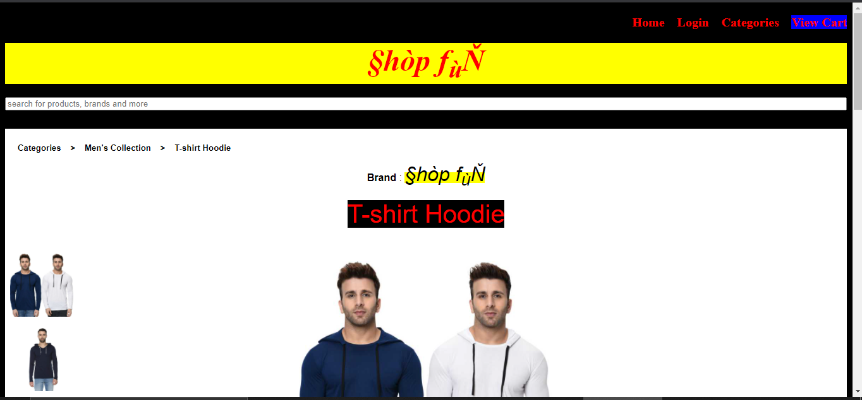

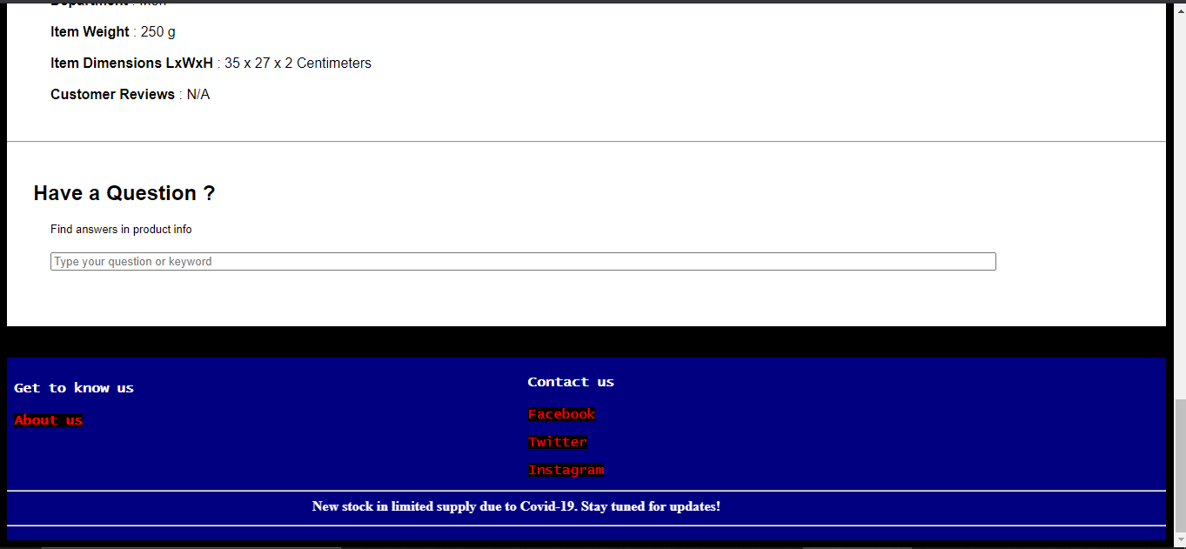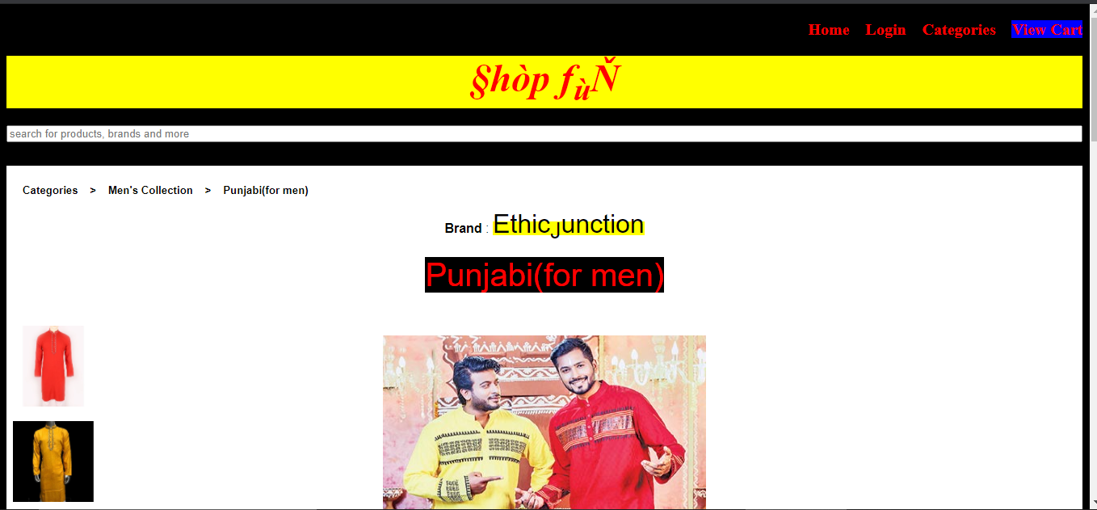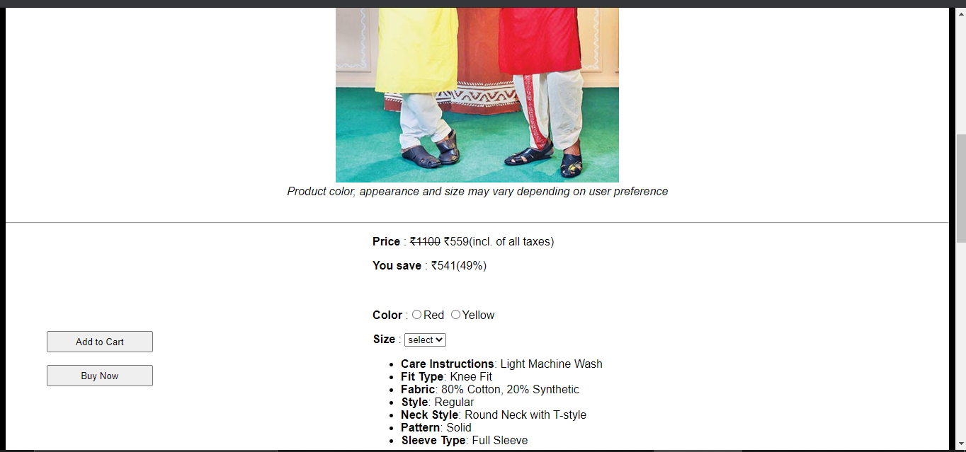

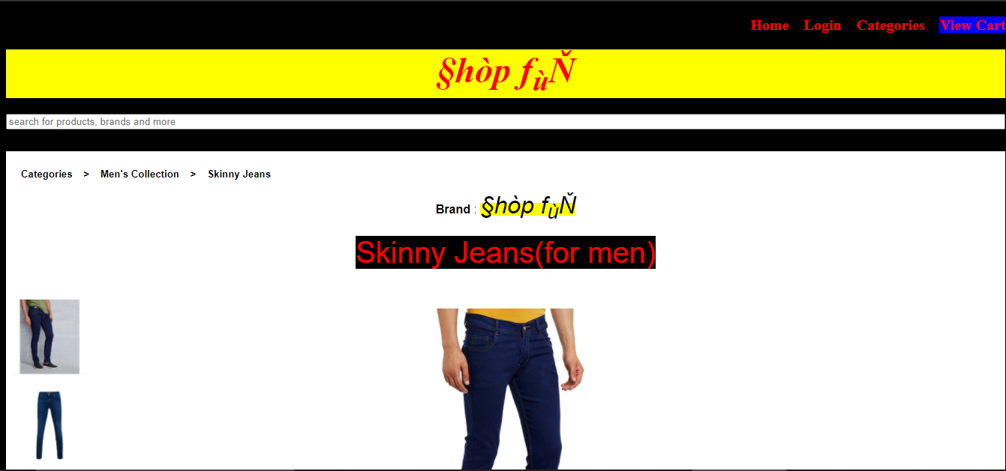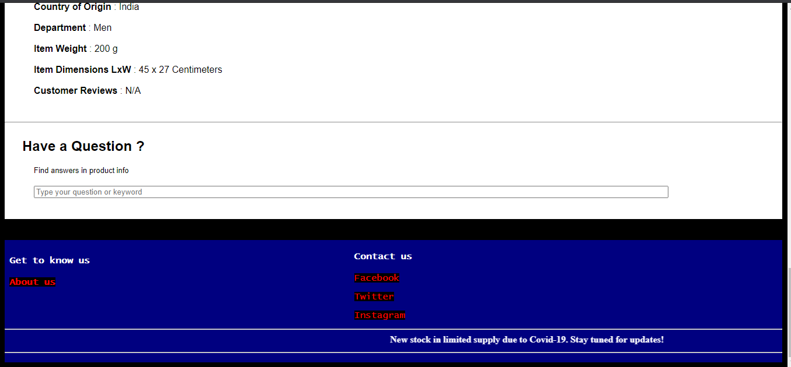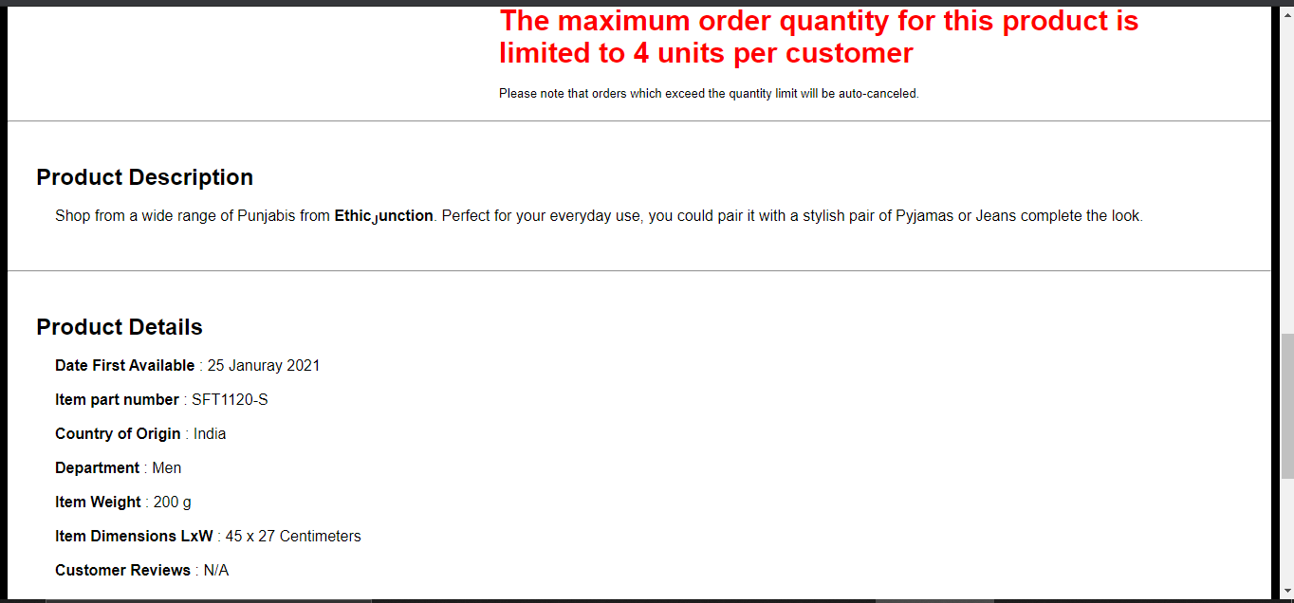

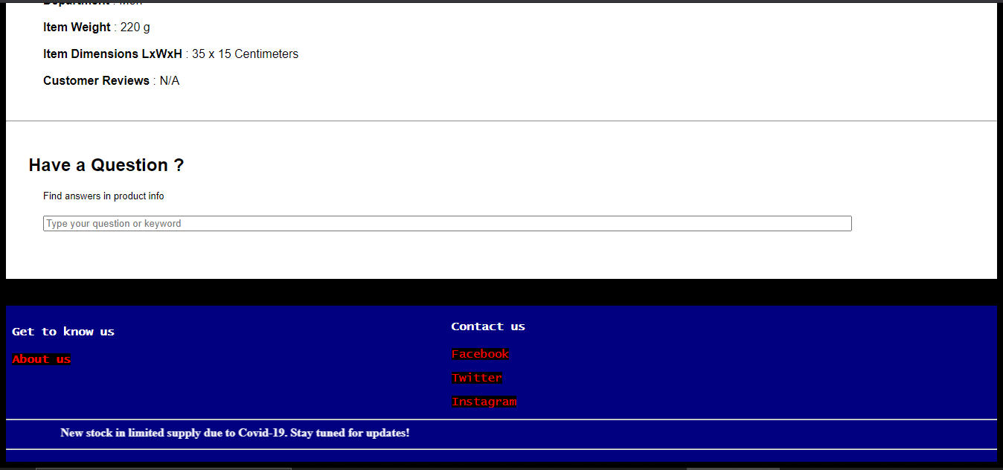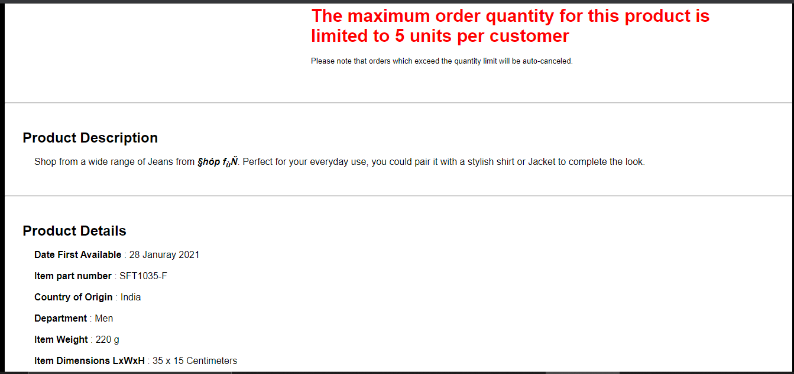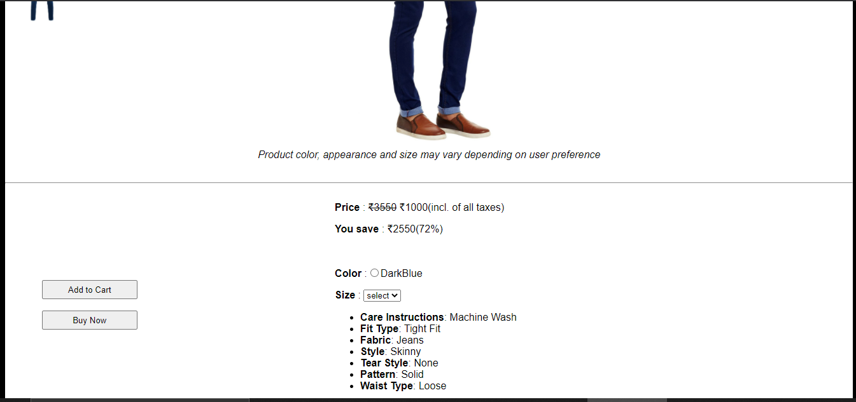

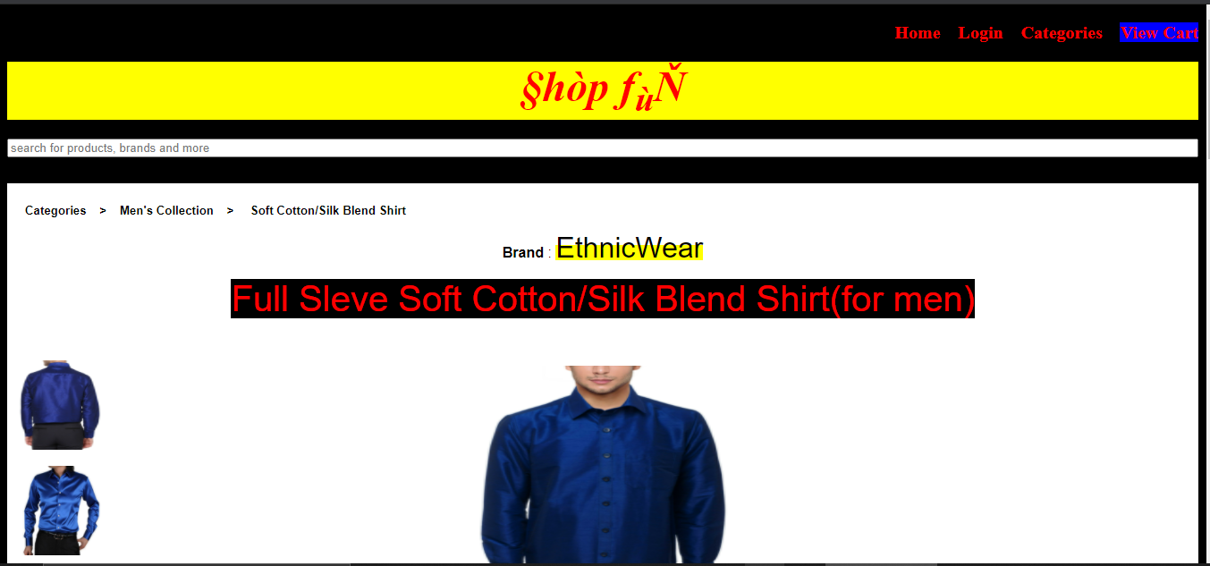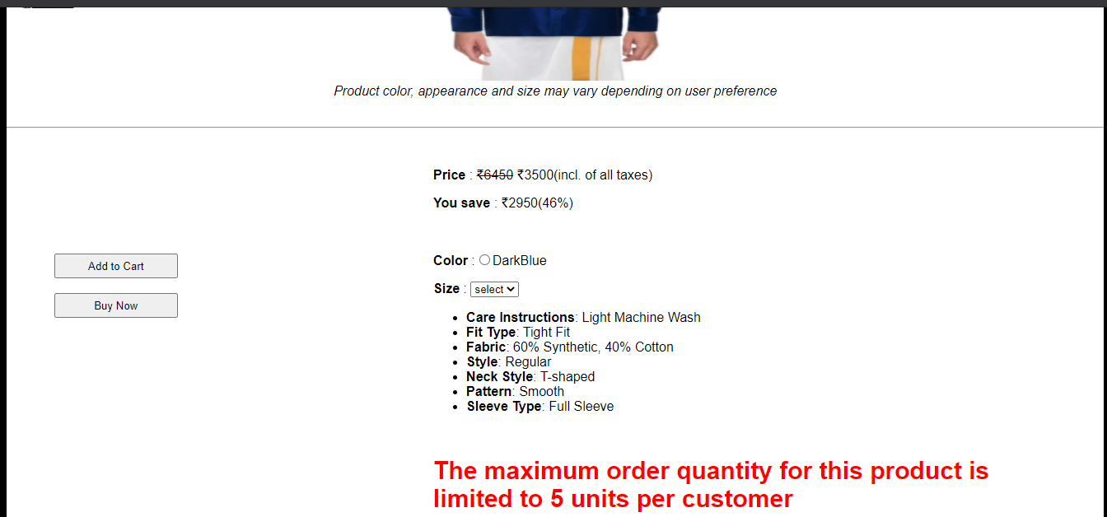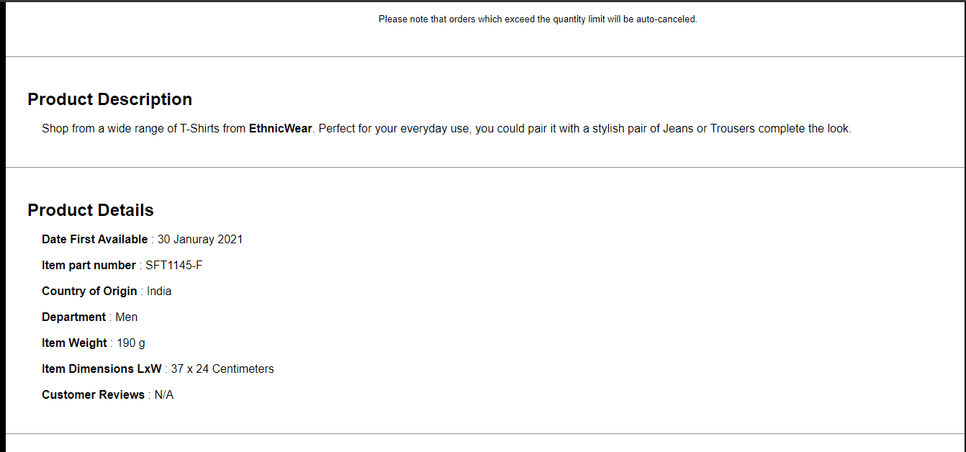

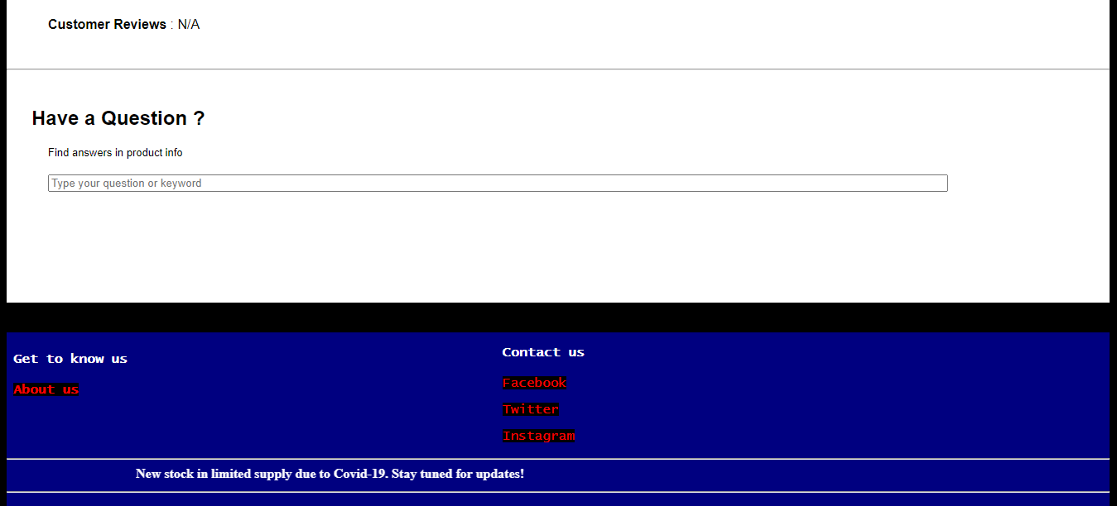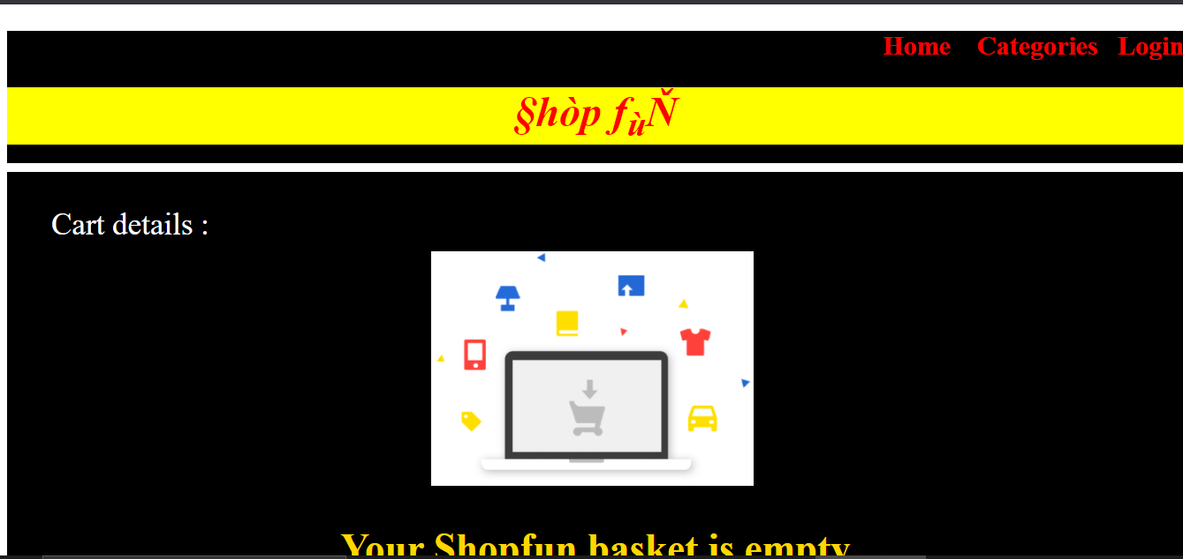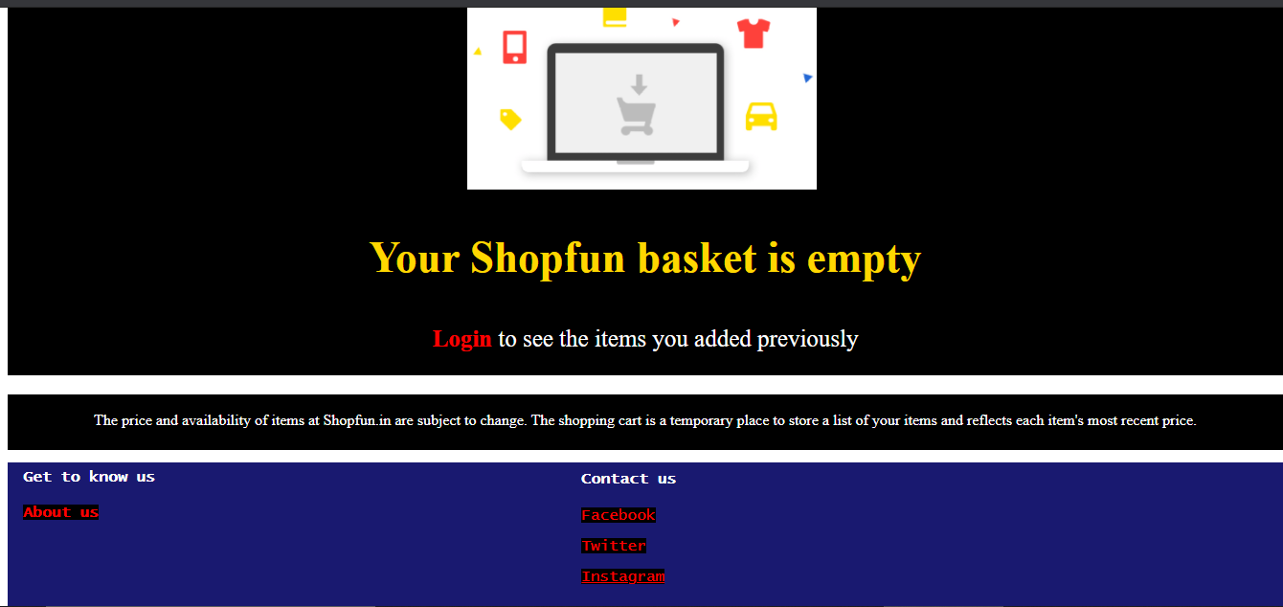

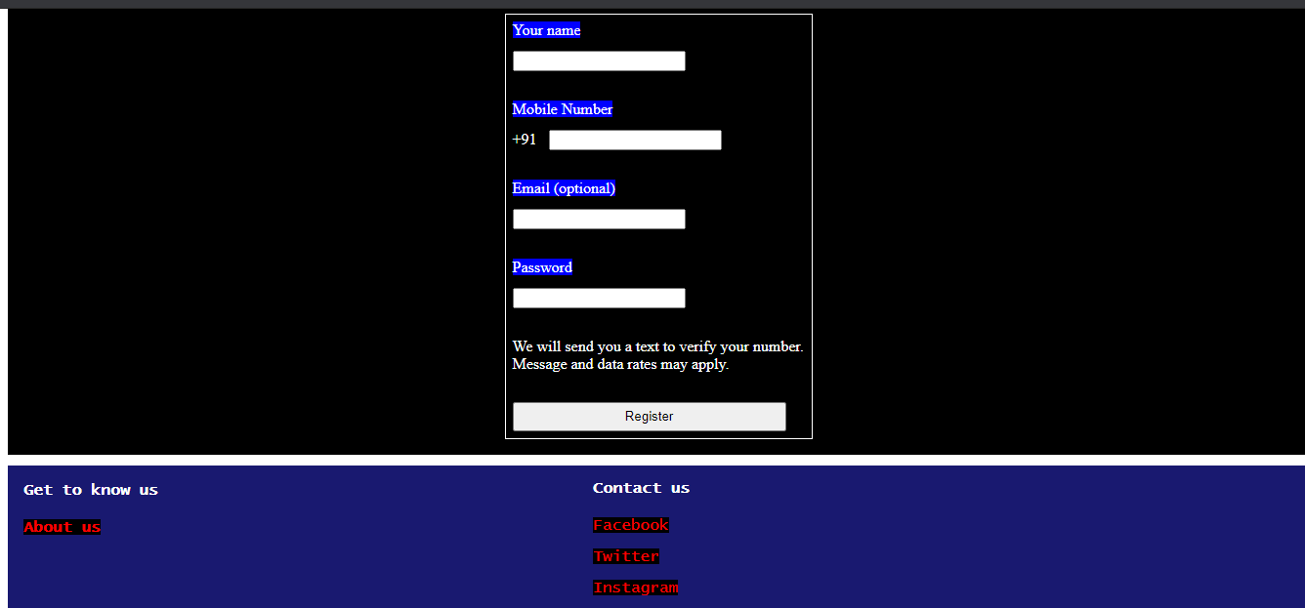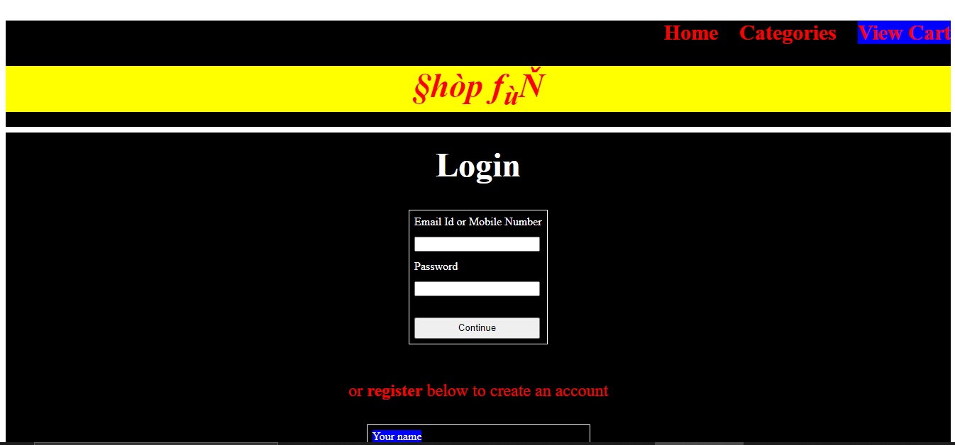

**Source code for Homepage :**

<!DOCTYPE html>

<html>

<head>

<title>Shop Fun : Home</title>

<link rel = "stylesheet" href = "styles1.css">

</head>

<body>

<p1><b>Login here</b></p1><br><br>

<input type = "text" id = "log" name = "log" size = "150" placeholder = "phone number/email"><br><br>

<p2>or</p2><br><br>

<p3><a href = "file:///G:/lab tech project/login/login.html"><b>Register</b></a></p3><!--hyperlink to login page --><br>

<p style = "text-align : right; font-size : 25px;"><a href = "file:///G:/lab tech project/categories/categories.html"><b>Categories</b></a>&nbsp;&nbsp;&nbsp;

<a href = "file:///G:/lab tech project/mens collection/men.html"><b><mark>Men</mark></b></a>&nbsp;&nbsp;&nbsp;

<a href = "file:///G:/lab tech project/womens collection/women.html"><b><mark>Women</mark></b></a>&nbsp;&nbsp;&nbsp;

<a href = "file:///G:/lab tech project/cart/cart.html"><b><span style = "background-color : blue">View Cart</span></b></a></p>

<hr class = "new1"><marquee><p4><b>Shipping and delivery is currently available within India only.</b></p4></marquee><hr class = "new1">

<div class="container">

<img src="homepage.jpg" alt="online-shopping" style="width:100%;">

<div class="centered1">§hòp <i>f</i><sub>û</sub></i>Ň</i></div>

<div class="centered2"><b>Iñdîà§ Be§t §hôppîg Åpp</b></div><br><br><br><br>

<div class="bottom-right">www.shopfun@gmail.com</div>

<div class="bottom-left"><h3>Get to know us</h3>

<p><a href = " "><b>About us</b></a></p></div>

<div class="centered3"><h3>Contact us</h3>

<p><b><a href = "https://www.facebook.com/">Facebook</a><br><br><a href = "https://twitter.com/">Twitter</a><br><br><a href = "https://www.instagram.com/">Instagram</b></a></p></div></div>

</body>

</html>

**Css code for Homepage :**

a:link

{

color: green;

background-color: transparent;

text-decoration: none;

}

a:visited

{

color: red;

background-color: transparent;

text-decoration: none;

}

a:hover

{

color: red;

background-color: transparent;

text-decoration: underline;

}

a:active

{

color: yellow;

background-color: transparent;

text-decoration: underline;

}

.container

{

position: absolute;

text-align: center;

bottom : 10px

color: white;

}

.bottom-right

{

position: absolute;

top:600px;

right: 16px;

color: white;

}

.bottom-left {

position: absolute;

bottom: -25px;

left: 16px;

color : white;

}

.centered1

{

position: absolute;

top: 1%;

left: 36%;

color:red;

background-color:yellow;

font-size : 750%;

}

.centered2

{

position: absolute;

top: 85%;

left: 45%;

color:blue;

background-color:yellow;

}

.centered3

{

position: absolute;

top: 89%;

left: 45%;

color:white;

}

body

{

background-color : black;

}

p1

{

color : CornflowerBlue;

}

p2

{

color : white;

}

p3

{

color : red;

font-size : 26px;

}

p4

{

color : white;

font family : Rockwell;

}

hr.new1

{

border: 1px solid red;

}

**Source code for Categories page :**

<!DOCTYPE html>

<html>

<head>

<title>Shop Fun : Categories</title>

<link rel = "stylesheet" href = "styles2.css">

</head>

<body>

<div class = "top">

<p style = "text-align : right; font-size : 20px;"><a href = "file:///G:/lab tech project/homepage/homepage.html"><b>Home</b></a>&nbsp;&nbsp;&nbsp;

<a href = "file:///G:/lab tech project/login/login.html"><b>Login</b></a>&nbsp;&nbsp;&nbsp;

<a href = "file:///G:/lab tech project/cart/cart.html"><b><span style = "background-color : blue">View Cart</span></b></a></p>

<h1><font size="800"><i>§hòp f<sub>ù</sub>Ň</i></font></h1>

<input type = "text" id = "search3" name = "search3" size = "185" placeholder = "search for products, brands and more"><br><br><br><br>

</div>

<div class = "middle">

<br><p style = "text-align : center; font-size : 20px;"><a href = "file:///G:/lab tech project/womens collection/women.html"><b><span style = "background-color : blue">Women's Collection</span></b></a><br></p>

<center><input type = "text" id = "search1" name = "search1" size = "100" placeholder = "search here for women's collections"></center><br><br>

<center><img src="categories1.jpg" alt="women-fashion" style="width:920px; height: 600px;"></center><br>

<p style = "text-align : center; font-size : 20px;"><a href = "file:///G:/lab tech project/mens collection/men.html"><b><span style = "background-color : blue">Men's Collection</span></b></a><br></p>

<center><input type = "text" id = "search2" name = "search2" size = "100" placeholder = "search here for men's collections"></center><br><br>

<center><img src="categories2.jpg" alt="men-fashion" style="width:920px; height: 600px;"></center></div>

<div class = "bottom">

<div class="bottom-left"><h4>Get to know us</h4>

<p><a href = " "><b><span style = "background-color : black">About us</span></b></a></p></div>

<div class="centered3"><h4><b>Contact us</b></h4>

<p><span style = "background-color : black"><a href = "https://www.facebook.com/">Facebook</a><br><br><a href = "https://twitter.com/">Twitter</a><br><br>

<a href = "https://www.instagram.com/">Instagram</span></a></p></div>

<br><br><br><br><br><br><br><br><hr><marquee><b>New stock in limited supply due to Covid-19. Stay tuned for updates!</b></marquee><hr>

</div>

</body>

</html>

**Css code for Categories page :**

a:link

{

color: green;

background-color: transparent;

text-decoration: none;

}

a:visited

{

color: red;

background-color: transparent;

text-decoration: none;

}

a:hover

{

color: red;

background-color: transparent;

text-decoration: underline;

}

a:active

{

color: yellow;

background-color: transparent;

text-decoration: underline;

}

h1

{

color : red;

background-color: yellow;

text-align: center;

}

body

{

background-color : black;

}

.top

{

background-color : black;

height : 180px;

width : 1332px;

}

.middle

{

background-color : #303030;

height : 1550px;

width : 1332px;

font-family: "Comic Sans MS", "Comic Sans", cursive;

}

.bottom

{

height : 210px;

width : 1332px;

background-color : DarkSlateBlue;

color : white ;

}

.centered3

{

position: absolute;

top: 280%;

left: 45%;

color:white;

font-family: "Lucida Console", "Courier New", monospace;

}

.bottom-left

{

position: absolute;

bottom: -1220px;

left: 16px;

color : white;

font-family: "Lucida Console", "Courier New", monospace;

}

**Source code for Women’s Collection page :**

<!DOCTYPE html>

<html>

<head>

<title>Shop Fun : Women's Collection</title>

<link rel = "stylesheet" href = "styles3.css">

</head>

<body>

<div class = "top">

<p style = "text-align : right; font-size : 20px;"><a href = "file:///G:/lab tech project/homepage/homepage.html"><b>Home</b></a>&nbsp;&nbsp;&nbsp;

<a href = "file:///G:/lab tech project/login/login.html"><b>Login</b></a>&nbsp;&nbsp;&nbsp;

<a href = "file:///G:/lab tech project/categories/categories.html"><b>Categories</b></a>&nbsp;&nbsp;&nbsp;

<a href = "file:///G:/lab tech project/cart/cart.html"><b><span style = "background-color : blue">View Cart</span></b></a></p>

<h1><font size="800"><i>§hòp f<sub>ù</sub>Ň</i></font></h1>

<input type = "text" id = "search3" name = "search3" size = "185" placeholder = "search for products, brands and more"><br><br><br><br></div>

<div class = "middle">

<div style="text-align: left">

<br><br><img src="wdress1.jpg" alt = "silk_blend_saree" width="200">

</div>

<div class = "w1"><a href = "file:///G:/lab tech project/womensaree/womensaree.html">Woven Fashion Silk Blend Saree(Green, Red)</a></div>

<div class = "w2"><mark>₹399</mark> &nbsp;&nbsp;<strike>₹1200</strike> save ₹801(67%) <br>

<b><span style = "background-color : blue">Free delivery on your first order from this category</b></div><br><br>

<div style="text-align: left">

<br><br><img src="wdress2.jpeg" alt = "maroon_anarkalian_kurti" width="210">

</div>

<div class = "w3"><a href = "file:///G:/lab tech project/womenkurti/kurti.html">Printed Rayon Anarkalian Kurti(Maroon)</a>

</div>

<div class = "w4"><mark>₹525</mark> &nbsp;&nbsp;<strike>₹1500</strike> save ₹975(65%) <br>

<b><span style = "background-color : blue">Free delivery on your first order from this category</b></div><br><br><br>

<div style="text-align: left">

<br><br><img src="wdress3.jpg" alt = "nighty-set" width="200">

</div>

<div class = "w5"><a href = "file:///G:/lab tech project/women_nightyset/nightyset.html">Nighty set(Orange, Skyblue, Seagreen)</a></div>

<div class = "w6"><mark>₹900</mark> &nbsp;&nbsp;<strike>₹2450</strike> save ₹1550(63%) <br>

<b><span style = "background-color : blue">Free delivery on your first order from this category</b></div><br><br><br>

<div style="text-align: left">

<br><br><img src="wdress4.jpg" alt = "jeans_jacket" width="220">

</div>

<div class = "w7"><a href = "file:///G:/lab tech project/womenjacket/womenjacket.html">Jeans & Jacket(Blue, White)</a></div>

<div class = "w8"><mark>₹2690</mark> &nbsp;&nbsp;<strike>₹6000</strike> save ₹3310(55%) <br>

<b><span style = "background-color : blue">Free delivery on your first order from this category</b></div><br><br><br>

</div>

<div class = "bottom">

<div class="bottom-left"><h4>Get to know us</h4>

<p><a href = " "><b><span style = "background-color : black">About us</span></b></a></p></div>

<div class="bottom-center"><h4><b>Contact us</b></h4>

<p><span style = "background-color : black"><a href = "https://www.facebook.com/">Facebook</a><br><br><a href = "https://twitter.com/">Twitter</a><br><br>

<a href = "https://www.instagram.com/">Instagram</span></a></p></div>

<br><br><br><br><br><br><br><br><hr><marquee><b>New stock in limited supply due to Covid-19. Stay tuned for updates!</b></marquee><hr>

</div>

</body>

</html>

**Css code for Women’s Collection page :**

a:link

{

color: green;

background-color: transparent;

text-decoration: none;

}

a:visited

{

color: red;

background-color: transparent;

text-decoration: none;

}

a:hover

{

color: red;

background-color: transparent;

text-decoration: underline;

}

a:active

{

color: yellow;

background-color: transparent;

text-decoration: underline;

}

h1

{

color : red;

background-color: yellow;

text-align: center;

}

body

{

background-color : black;

}

.top

{

background-color : black;

height : 180px;

width : 1332px;

}

.middle

{

background-color : black;

height : 1550px;

width : 1332px;

font-family: "Comic Sans MS", "Comic Sans", cursive;

}

.bottom

{

height : 210px;

width : 1332px;

background-color : DarkSlateBlue;

color : white ;

}

.bottom-center

{

position: absolute;

top: 280%;

left: 45%;

color:white;

font-family: "Lucida Console", "Courier New", monospace;

}

.bottom-left {

position: absolute;

bottom: -1220px;

left: 16px;

color : white;

font-family: "Lucida Console", "Courier New", monospace;

}

.w1

{

position: absolute;

top: 280px;

left: 246px;

color : white;

background-color : white;

font-size : 40px;

font-family: "Times New Roman", Times, serif;

}

.w2

{

position: absolute;

top: 410px;

left: 246px;

color : white;

font-size : 20px;

font family : Arial, Helvetica, sans-serif;

}

.w3

{

position: absolute;

top: 670px;

left: 246px;

color : white;

background-color : white;

font-size : 40px;

font-family: "Times New Roman", Times, serif;

}

.w4

{

position: absolute;

top: 790px;

left: 246px;

color : white;

font-size : 20px;

font family : Arial, Helvetica, sans-serif;

}

.w5

{

position: absolute;

top: 1050px;

left: 246px;

color : white;

background-color : white;

font-size : 40px;

font-family: "Times New Roman", Times, serif;

}

.w6

{

position: absolute;

top: 1180px;

left: 246px;

color : white;

font-size : 20px;

font family : Arial, Helvetica, sans-serif;

}

.w7

{

position: absolute;

top: 1420px;

left: 246px;

color : white;

background-color : white;

font-size : 40px;

font-family: "Times New Roman", Times, serif;

}

.w8

{

position: absolute;

top: 1520px;

left: 246px;

color : white;

font-size : 20px;

font family : Arial, Helvetica, sans-serif;

}

**Source code for Woven Fashion Silk Blend Saree page :**

<!DOCTYPE html>

<html>

<head>

<title>Shop Fun : Silk Blend Saree</title>

<link rel = "stylesheet" href = "women1.css">

</head>

<body>

<div class = "top">

<p style = "text-align : right; font-size : 20px;"><a href = "file:///G:/lab tech project/homepage/homepage.html"><b>Home</b></a>&nbsp;&nbsp;&nbsp;

<a href = "file:///G:/lab tech project/login/login.html"><b>Login</b></a>&nbsp;&nbsp;&nbsp;

<a href = "file:///G:/lab tech project/categories/categories.html"><b>Categories</b></a>&nbsp;&nbsp;&nbsp;

<a href = "file:///G:/lab tech project/cart/cart.html"><b><span style = "background-color : blue">View Cart</span></b></a></p>

<h1><font size="800"><i>§hòp f<sub>ù</sub>Ň</i></font></h1>

<input type = "text" id = "search3" name = "search3" size = "185" placeholder = "search for products, brands and more"><br><br><br><br>

</div>

<div class = "middle">

<br><h5 class="m5">Categories&nbsp;&nbsp;&nbsp;&nbsp;>&nbsp;&nbsp;&nbsp;&nbsp;Women's Collection&nbsp;&nbsp;&nbsp;&nbsp;>&nbsp;&nbsp;&nbsp;&nbsp;Silk Blend Saree</h5>

<center>

<p><b>Brand</b> : <span style = "background-color : yellow"><font size="6">Ethic<sub>J</sub>unctioŇ</font></span></p>

<p1>Woven Fashion Silk Blend Saree</p1>

<div class = "top-left1">

<img src="saree1.jpg" alt="silk-blend_saree1" class ="thumbnail2" width="100" height="140"></div>

<div class = "top-left2">

<br><img src="saree2.jpg" alt="red_saree" class ="thumbnail2" width="100" height="130">

</div>

<div class = "top-left3">

<br><img src="saree3.jpg" alt="green_saree" class ="thumbnail2" width="100" height="130">

</div>

<figure>

<br><img src="saree1.jpg" alt="silk-blend_saree" class ="thumbnail" width="400" height="500">

<figcaption><i>Product color, appearance and size may vary depending on user preference</i></figcaption><br>

</figure>

</center>

<hr>

<br><br><br><br><br><br><br><br>&nbsp;&nbsp;&nbsp;&nbsp;&nbsp;&nbsp;&nbsp;&nbsp;&nbsp;&nbsp;&nbsp;&nbsp;

<input type="submit" value="Add to Cart" style="height:30px; width:150px" onclick="alert('Added to cart !')"><br><br>

&nbsp;&nbsp;&nbsp;&nbsp;&nbsp;&nbsp;&nbsp;&nbsp;&nbsp;&nbsp;&nbsp;&nbsp;

<input type="submit" value="Buy Now" style="height:30px; width:150px" onclick="alert('Please log in first !!')">

<div class = "centered">

<p><b><br><br><br>Price</b> : <strike>₹1200</strike> ₹399(incl. of all taxes)</p>

<p><b>You save</b> : ₹801(67%)</p><br>

<p><b>Color</b> :<input type=radio name=initial>Green

<input type=radio name=initial>Red

<input type=radio name=initial>Green and Red</p>

<label for="size"><b>Size</b> :</label>

<select name=size>

<option value="select">select

<option value="s"><b>S</b>

<option value="M"><b>M</b>

<option value="L"><b>L</b>

<option value="XL"><b>XL</b>

</select>

<br><ul style= "list-style-type:disc; font-size:100%">

<li><b>Care Instructions</b>: Light Machine Wash</li>

<li><b>Fit Type</b>: Regular Fit</li>

<li><b>Fabric</b>: 30% Cotton, 70% Synthetic</li>

<li><b>Style</b>: Regular</li>

<li><b>Pattern</b>: Checkered and solid</li>

<li><b>Drape Style</b>: Solid (with custom design)</li>

</ul>

<br><br><p2><b>The maximum order quantity for this product is<br>

limited to 2 units per customer</b></p2>

<p><font size="2">Please note that orders which exceed the quantity limit will be auto-canceled.</font></p>

</div>

<br><br><br><br><br><br><br><br><br><br><br><br><br><br><hr>

<br><br><h2 class="m2"><b>Product Description</b></h2><br>

<p class="m1">Shop from a wide range of sarees from <b>Ethic<sub>J</sub>unctioŇ</b>. Perfect for your

outing needs, you could pair it with a stylish set of jewellery to complete the look.</p><br><br><hr>

<br><br><h2 class="m2"><b>Product Details</b></h2><br>

<p class="m1"><b>Date First Available</b> : 10 Januray 2021<br><br>

<b>Item part number</b> : SFT1225-S<br><br>

<b>Country of Origin</b> : India<br><br>

<b>Department</b> : Women<br><br>

<b>Item Weight</b> : 210 g<br><br>

<b>Item Dimensions LxW</b> : 45 x 20 Centimeters<br><br>

<b>Customer Reviews</b> : N/A</p><br><br>

<hr>

<br><br><h2 class="m2">Have a Question ?</h2><br>

<p class="m1"><font size = "2">Find answers in product info</font><br><br>

<input type = "text" id = "searchq" name = "searchq" size = "150" placeholder = "Type your question or keyword"></p><br><br><br>

</div>

<br><br><div class = "bottom">

<div class="bottom-left"><h4>Get to know us</h4>

<p><a href = " "><b><span style = "background-color : black">About us</span></b></a></p></div>

<div class="bottom-center"><h4><b>Contact us</b></h4>

<p><span style = "background-color : black"><a href = "https://www.facebook.com/">Facebook</a><br><br><a href = "https://twitter.com/">Twitter</a><br><br>

<a href = "https://www.instagram.com/">Instagram</span></a></p></div>

<br><br><br><br><br><br><br><br><hr><marquee><b>New stock in limited supply due to Covid-19. Stay tuned for updates!</b></marquee><hr></div>

</body>

</html>

**Css code for Woven Fashion Silk Blend Saree page :**

a:link

{

color: green;

background-color: transparent;

text-decoration: none;

}

a:visited

{

color: red;

background-color: transparent;

text-decoration: none;

}

a:hover

{

color: red;

background-color: transparent;

text-decoration: underline;

}

a:active

{

color: yellow;

background-color: transparent;

text-decoration: underline;

}

h1

{

color : red;

background-color: yellow;

text-align: center;

}

h2.m2

{

margin : 0px 0px 0px 30px;

}

h5.m5

{

margin : 5px 0px 0px 20px;

}

p.m1

{

margin : 0px 0px 0px 50px;

}

p1

{

color : red;

background-color : black;

font-size : 40px;

}

p2

{

color : red;

font-size : 30px;

}

body

{

background-color : black;

}

.top

{

background-color : black;

height : 180px;

width : 1332px;

}

.top-left1

{

position: absolute;

top: 398px;

left: 16px;

}

.top-left2

{

position: absolute;

top: 520px;

left: 16px;

}

.top-left3

{

position: absolute;

top: 660px;

left: 16px;

}

.top-right

{

position: absolute;

top: 990px;

right: 174px;

}

.centered

{

position: absolute;

top: 145%;

left: 39%;

}

.middle

{

background-color : white;

height : 1953px;

width : 1332px;

font-family: Arial, Helvetica, sans-serif;

}

.bottom

{

height : 210px;

width : 1332px;

background-color : navy;

color : white ;

}

.bottom-center

{

position: absolute;

top: 350%;

left: 45%;

color:white;

font-family: "Lucida Console", "Courier New", monospace;

}

.bottom-left {

position: absolute;

bottom: -1660px;

left: 16px;

color : white;

font-family: "Lucida Console", "Courier New", monospace;

}

.thumbnail:hover

{

position:relative;

top:25px;

left:35px;

width:600px;

height:auto;

display:block;

z-index:1;

}

.thumbnail2:hover

{

position:relative;

top:25px;

left:35px;

width:400px;

height:auto;

display:block;

z-index:1;

}

**Source code for Printed Rayon Anarkalian Kurti page :**

<!DOCTYPE html>

<html>

<head>

<title>Shop Fun : Printed Rayon Anarkalian Kurti</title>

<link rel = "stylesheet" href = "women2.css">

</head>

<body>

<div class = "top">

<p style = "text-align : right; font-size : 20px;"><a href = "file:///G:/lab tech project/homepage/homepage.html"><b>Home</b></a>&nbsp;&nbsp;&nbsp;

<a href = "file:///G:/lab tech project/login/login.html"><b>Login</b></a>&nbsp;&nbsp;&nbsp;

<a href = "file:///G:/lab tech project/categories/categories.html"><b>Categories</b></a>&nbsp;&nbsp;&nbsp;

<a href = "file:///G:/lab tech project/cart/cart.html"><b><span style = "background-color : blue">View Cart</span></b></a></p>

<h1><font size="800"><i>§hòp f<sub>ù</sub>Ň</i></font></h1>

<input type = "text" id = "search3" name = "search3" size = "185" placeholder = "search for products, brands and more"><br><br><br><br>

</div>

<div class = "middle">

<br><h5 class="m5">Categories&nbsp;&nbsp;&nbsp;&nbsp;>&nbsp;&nbsp;&nbsp;&nbsp;Women's Collection&nbsp;&nbsp;&nbsp;&nbsp;>&nbsp;&nbsp;&nbsp;&nbsp;Printed Rayon

Anarkalian Kurti</h5>

<center>

<p><b>Brand</b> : <span style = "background-color : yellow"><font size="6">Ethic<sub>J</sub>unctioŇ</font></span></p>

<p1>Printed Rayon Anarkalian Kurti</p1>

<div class = "top-left1">

<img src="kurti.jpeg" alt="rayon_anarkalian_kurti" class ="thumbnail2" width="100" height="100"></div>

<div class = "top-left2">

<img src="kurti2.jpeg" alt="rayon_anarkalian_kurti2" class ="thumbnail2" width="100" height="130">

</div>

<figure>

<br><img src="kurti.jpeg" alt="rayon_anarkalian_kurti" class ="thumbnail" width="400" height="500">

<figcaption><i>Product color, appearance and size may vary depending on user preference</i></figcaption><br>

</figure>

</center><hr>

<br><br><br><br><br><br><br><br>&nbsp;&nbsp;&nbsp;&nbsp;&nbsp;&nbsp;&nbsp;&nbsp;&nbsp;&nbsp;&nbsp;&nbsp;

<input type="submit" value="Add to Cart" style="height:30px; width:150px" onclick="alert('Added to cart !')"><br><br>

&nbsp;&nbsp;&nbsp;&nbsp;&nbsp;&nbsp;&nbsp;&nbsp;&nbsp;&nbsp;&nbsp;&nbsp;

<input type="submit" value="Buy Now" style="height:30px; width:150px" onclick="alert('Please log in first !!')">

<div class = "centered">

<p><b><br><br><br>Price</b> : <strike>₹1500</strike> ₹525(incl. of all taxes)</p>

<p><b>You save</b> : ₹975(65%)</p><br>

<p><b>Color</b> :<input type=radio name=initial>Maroon (with black borders)

<input type=radio name=initial>Maroon</p>

<label for="size"><b>Size</b> :</label>

<select name=size>

<option value="select">select

<option value="s"><b>S</b>

<option value="M"><b>M</b>

<option value="L"><b>L</b>

<option value="XL"><b>XL</b>

</select>

<br><ul style= "list-style-type:disc; font-size:100%">

<li><b>Care Instructions</b>: Machine Wash</li>

<li><b>Fit Type</b>: Regular Fit</li>

<li><b>Fabric</b>: 70% Rayon, 30% Synthetic</li>

<li><b>Style</b>: Printed</li>

<li><b>Pattern</b>: Checkered and solid</li>

<li><b>Neck Style</b>: Round </li>

</ul>

<br><br><p2><b>The maximum order quantity for this product is<br>

limited to 2 units per customer</b></p2>

<p><font size="2">Please note that orders which exceed the quantity limit will be auto-canceled.</font></p>

</div>

<br><br><br><br><br><br><br><br><br><br><br><br><br><br><hr>

<br><br><h2 class="m2"><b>Product Description</b></h2><br>

<p class="m1">Shop from a wide range of kurtis from <b>Ethic<sub>J</sub>unctioŇ</b>. Perfect for your

everyday needs, you could pair it with slacks and a stylish set of jewellery to complete the look.</p><br><br><hr>

<br><br><h2 class="m2"><b>Product Details</b></h2><br>

<p class="m1"><b>Date First Available</b> : 11 Januray 2021<br><br>

<b>Item part number</b> : SFT1226-S<br><br>

<b>Country of Origin</b> : India<br><br>

<b>Department</b> : Women<br><br>

<b>Item Weight</b> : 200 g<br><br>

<b>Item Dimensions LxW</b> : 36 x 22 Centimeters<br><br>

<b>Customer Reviews</b> : N/A</p><br><br><hr>

<br><br><h2 class="m2">Have a Question ?</h2><br>

<p class="m1"><font size = "2">Find answers in product info</font><br><br>

<input type = "text" id = "searchq" name = "searchq" size = "150" placeholder = "Type your question or keyword"></p><br><br><br></div>

<br><br><div class = "bottom">

<div class="bottom-left"><h4>Get to know us</h4>

<p><a href = " "><b><span style = "background-color : black">About us</span></b></a></p></div>

<div class="bottom-center"><h4><b>Contact us</b></h4>

<p><span style = "background-color : black"><a href = "https://www.facebook.com/">Facebook</a><br><br><a href = "https://twitter.com/">Twitter</a><br><br>

<a href = "https://www.instagram.com/">Instagram</span></a></p></div>

<br><br><br><br><br><br><br><br><hr><marquee><b>New stock in limited supply due to Covid-19. Stay tuned for updates!</b></marquee><hr></div>

</body>

</html>

**Css code for Printed Rayon Anarkalian Kurti page :**

a:link

{

color: green;

background-color: transparent;

text-decoration: none;

}

a:visited

{

color: red;

background-color: transparent;

text-decoration: none;

}

a:hover

{

color: red;

background-color: transparent;

text-decoration: underline;

}

a:active

{

color: yellow;

background-color: transparent;

text-decoration: underline;

}

h1

{

color : red;

background-color: yellow;

text-align: center;

}

h2.m2

{

margin : 0px 0px 0px 30px;

}

h5.m5

{

margin : 5px 0px 0px 20px;

}

p.m1

{

margin : 0px 0px 0px 50px;

}

p1

{

color : red;

background-color : black;

font-size : 40px;

}

p2

{

color : red;

font-size : 30px;

}

body

{

background-color : black;

}

.top

{

background-color : black;

height : 180px;

width : 1332px;

}

.top-left1

{

position: absolute;

top: 398px;

left: 16px;

}

.top-left2

{

position: absolute;

top: 520px;

left: 16px;

}

.top-left3

{

position: absolute;

top: 660px;

left: 16px;

}

.top-right

{

position: absolute;

top: 990px;

right: 174px;

}

.centered

{

position: absolute;

top: 145%;

left: 39%;

}

.middle

{

background-color : white;

height : 1953px;

width : 1332px;

font-family: Arial, Helvetica, sans-serif;

}

.bottom

{

height : 210px;

width : 1332px;

background-color : navy;

color : white ;

}

.bottom-center

{

position: absolute;

top: 350%;

left: 45%;

color:white;

font-family: "Lucida Console", "Courier New", monospace;

}

.bottom-left {

position: absolute;

bottom: -1660px;

left: 16px;

color : white;

font-family: "Lucida Console", "Courier New", monospace;

}

.thumbnail:hover

{

position:relative;

top:25px;

left:35px;

width:600px;

height:auto;

display:block;

z-index:1;

}

.thumbnail2:hover

{

position:relative;

top:25px;

left:35px;

width:400px;

height:auto;

display:block;

z-index:1;

}

**Source code for Nighty Set page :**

<!DOCTYPE html>

<html>

<head>

<title>Shop Fun : Nighty Set</title>

<link rel = "stylesheet" href = "women3.css">

</head>

<body>

<div class = "top">

<p style = "text-align : right; font-size : 20px;"><a href = "file:///G:/lab tech project/homepage/homepage.html"><b>Home</b></a>&nbsp;&nbsp;&nbsp;

<a href = "file:///G:/lab tech project/login/login.html"><b>Login</b></a>&nbsp;&nbsp;&nbsp;

<a href = "file:///G:/lab tech project/categories/categories.html"><b>Categories</b></a>&nbsp;&nbsp;&nbsp;

<a href = "file:///G:/lab tech project/cart/cart.html"><b><span style = "background-color : blue">View Cart</span></b></a></p>

<h1><font size="800"><i>§hòp f<sub>ù</sub>Ň</i></font></h1>

<input type = "text" id = "search3" name = "search3" size = "185" placeholder = "search for products, brands and more"><br><br><br><br>

</div>

<div class = "middle">

<br><h5 class="m5">Categories&nbsp;&nbsp;&nbsp;&nbsp;>&nbsp;&nbsp;&nbsp;&nbsp;Women's Collection&nbsp;&nbsp;&nbsp;&nbsp;>&nbsp;&nbsp;&nbsp;&nbsp;Nighty Set</h5>

<center>

<p><b>Brand</b> : <span style = "background-color : yellow"><font size="6">ALEOMART</font></span></p>

<p1>Nighty Set</p1>

<div class = "top-left1">

<img src="nighty1.jpg" alt="orange_nighty" class ="thumbnail2" width="100" height="100">

</div>

<div class = "top-left2">

<br><img src="nighty2.jpg" alt="blue_nighty" class ="thumbnail2" width="100" height="110">

</div>

<div class = "top-left3">

<br><img src="nighty3.jpeg" alt="green_nighty" class ="thumbnail2" width="100" height="150">

</div>

<figure>

<br><img src="nighty.jpg" alt="nighty_set" class ="thumbnail" width="400" height="500">

<figcaption><i>Product color, appearance and size may vary depending on user preference</i></figcaption><br>

</figure>

</center>

<hr>

<br><br><br><br><br><br><br><br>&nbsp;&nbsp;&nbsp;&nbsp;&nbsp;&nbsp;&nbsp;&nbsp;&nbsp;&nbsp;&nbsp;&nbsp;

<input type="submit" value="Add to Cart" style="height:30px; width:150px" onclick="alert('Added to cart !')"><br><br>

&nbsp;&nbsp;&nbsp;&nbsp;&nbsp;&nbsp;&nbsp;&nbsp;&nbsp;&nbsp;&nbsp;&nbsp;

<input type="submit" value="Buy Now" style="height:30px; width:150px" onclick="alert('Please log in first !!')">

<div class = "centered">

<p><b><br><br><br>Price</b> : <strike>₹2450</strike> ₹900(incl. of all taxes)</p>

<p><b>You save</b> : ₹1550(63%)</p><br>

<p><b>Color</b> :<input type=radio name=initial>Orange

<input type=radio name=initial>Blue

<input type=radio name=initial>Green</p>

<label for="size"><b>Size</b> :</label>

<select name=size>

<option value="select">select

<option value="s"><b>S</b>

<option value="M"><b>M</b>

<option value="L"><b>L</b>

<option value="XL"><b>XL</b>

</select>

<br><ul style= "list-style-type:disc; font-size:100%">

<li><b>Care Instructions</b>: Machine Wash</li>

<li><b>Fit Type</b>: Regular Fit</li>

<li><b>Fabric</b>: Cotton</li>

<li><b>Style</b>: Regular, sleveless</li>

<li><b>Pattern</b>: Checkered</li>

<li><b>Neck Style</b>: Boxed </li>

</ul>

<br><br><p2><b>The maximum order quantity for this product is<br>

limited to 1 unit per customer</b></p2>

<p><font size="2">Please note that orders which exceed the quantity limit will be auto-canceled.</font></p>

</div>

<br><br><br><br><br><br><br><br><br><br><br><br><br><br><hr>

<br><br><h2 class="m2"><b>Product Description</b></h2><br>

<p class="m1">Shop from a wide range of nighty sets from <b>ALEOMART</b>. Perfect for your

everyday wear, with fully 100% cotton fabric, enjoy the comfort of night garments like never before. Guranteed to last long through

multiple machine washes.</p><br><br><hr>

<br><br><h2 class="m2"><b>Product Details</b></h2><br>

<p class="m1"><b>Date First Available</b> : 13 Januray 2021<br><br>

<b>Item part number</b> : SFT1227-S<br><br>

<b>Country of Origin</b> : India<br><br>

<b>Department</b> : Women<br><br>

<b>Item Weight</b> : 180g(per item)<br><br>

<b>Item Dimensions LxW</b> : 40 x 20 Centimeters(per item)<br><br>

<b>Customer Reviews</b> : N/A</p><br><br>

<hr>

<br><br><h2 class="m2">Have a Question ?</h2><br>

<p class="m1"><font size = "2">Find answers in product info</font><br><br>

<input type = "text" id = "searchq" name = "searchq" size = "150" placeholder = "Type your question or keyword"></p><br><br><br>

</div>

<br><br><div class = "bottom">

<div class="bottom-left"><h4>Get to know us</h4>

<p><a href = " "><b><span style = "background-color : black">About us</span></b></a></p></div>

<div class="bottom-center"><h4><b>Contact us</b></h4>

<p><span style = "background-color : black"><a href = "https://www.facebook.com/">Facebook</a><br><br><a href = "https://twitter.com/">Twitter</a><br><br>

<a href = "https://www.instagram.com/">Instagram</span></a></p></div>

<br><br><br><br><br><br><br><br><hr><marquee><b>New stock in limited supply due to Covid-19. Stay tuned for updates!</b></marquee><hr>

</div>

</body>

</html>

**Css code for Nighty Set page :**

a:link

{

color: green;

background-color: transparent;

text-decoration: none;

}

a:visited

{

color: red;

background-color: transparent;

text-decoration: none;

}

a:hover

{

color: red;

background-color: transparent;

text-decoration: underline;

}

a:active

{

color: yellow;

background-color: transparent;

text-decoration: underline;

}

h1

{

color : red;

background-color: yellow;

text-align: center;

}

h2.m2

{

margin : 0px 0px 0px 30px;

}

h5.m5

{

margin : 5px 0px 0px 20px;

}

p.m1

{

margin : 0px 0px 0px 50px;

}

p1

{

color : red;

background-color : black;

font-size : 40px;

}

p2

{

color : red;

font-size : 30px;

}

body

{

background-color : black;

}

.top

{

background-color : black;

height : 180px;

width : 1332px;

}

.top-left1

{

position: absolute;

top: 398px;

left: 16px;

}

.top-left2

{

position: absolute;

top: 520px;

left: 16px;

}

.top-left3

{

position: absolute;

top: 660px;

left: 16px;

}

.top-right

{

position: absolute;

top: 990px;

right: 174px;

}

.centered

{

position: absolute;

top: 143%;

left: 39%;

}

.middle

{

background-color : white;

height : 1953px;

width : 1332px;

font-family: Arial, Helvetica, sans-serif;

}

.bottom

{

height : 210px;

width : 1332px;

background-color : navy;

color : white ;

}

.bottom-center

{

position: absolute;

top: 350%;

left: 45%;

color:white;

font-family: "Lucida Console", "Courier New", monospace;

}

.bottom-left {

position: absolute;

bottom: -1660px;

left: 16px;

color : white;

font-family: "Lucida Console", "Courier New", monospace;

}

.thumbnail:hover

{

position:relative;

top:25px;

left:35px;

width:600px;

height:auto;

display:block;

z-index:1;

}

.thumbnail2:hover

{

position:relative;

top:25px;

left:35px;

width:400px;

height:auto;

display:block;

z-index:1;

}

**Source code for Jeans & Jacket page :**

<!DOCTYPE html>

<html>

<head>

<title>Shop Fun : Jeans & Jacket</title>

<link rel = "stylesheet" href = "women4.css">

</head>

<body>

<div class = "top">

<p style = "text-align : right; font-size : 20px;"><a href = "file:///G:/lab tech project/homepage/homepage.html"><b>Home</b></a>&nbsp;&nbsp;&nbsp;

<a href = "file:///G:/lab tech project/login/login.html"><b>Login</b></a>&nbsp;&nbsp;&nbsp;

<a href = "file:///G:/lab tech project/categories/categories.html"><b>Categories</b></a>&nbsp;&nbsp;&nbsp;

<a href = "file:///G:/lab tech project/cart/cart.html"><b><span style = "background-color : blue">View Cart</span></b></a></p>

<h1><font size="800"><i>§hòp f<sub>ù</sub>Ň</i></font></h1>

<input type = "text" id = "search3" name = "search3" size = "185" placeholder = "search for products, brands and more"><br><br><br><br>

</div>

<div class = "middle">

<br><h5 class="m5">Categories&nbsp;&nbsp;&nbsp;&nbsp;>&nbsp;&nbsp;&nbsp;&nbsp;Women's Collection&nbsp;&nbsp;&nbsp;&nbsp;>&nbsp;&nbsp;&nbsp;&nbsp;Jeans & Jacket</h5>

<center>

<p><b>Brand</b> : <span style = "background-color : yellow"><font size="6"><strike>H</strike> <strike>a</strike> <strike>d</strike> <strike>e</strike>

<strike>t</strike> <strike>e</strike></font></span></p>

<p1>Jeans & Jacket(combo)</p1>

<div class = "top-left1">

<img src="wdress4.jpg" alt="jeans_and_jacket" class ="thumbnail2" width="100" height="100">

</div>

<div class = "top-left2">

<br><img src="wjacket.jpg" alt="jakcet" class ="thumbnail2" width="100" height="120">

</div>

<div class = "top-left3">

<br><img src="wjeans.jpg" alt="jeans" class ="thumbnail2" width="100" height="120">

</div>

<figure>

<br><img src="wdress4.jpg" alt="jeans_and_jacket" class ="thumbnail" width="400" height="400">

<figcaption><i>Product color, appearance and size may vary depending on user preference</i></figcaption><br>

</figure>

</center>

<hr>

<br><br><br><br><br><br><br><br>&nbsp;&nbsp;&nbsp;&nbsp;&nbsp;&nbsp;&nbsp;&nbsp;&nbsp;&nbsp;&nbsp;&nbsp;

<input type="submit" value="Add to Cart" style="height:30px; width:150px" onclick="alert('Added to cart !')"><br><br>

&nbsp;&nbsp;&nbsp;&nbsp;&nbsp;&nbsp;&nbsp;&nbsp;&nbsp;&nbsp;&nbsp;&nbsp;

<input type="submit" value="Buy Now" style="height:30px; width:150px" onclick="alert('Please log in first !!')">

<div class = "centered">

<p><b><br><br><br>Price</b> : <strike>₹6000</strike> ₹2690(incl. of all taxes)</p>

<p><b>You save</b> : ₹3310(55%)</p><br>

<p><b>Color</b> :<input type=radio name=initial>Light Blue & White

<input type=radio name=initial>Blue

<input type=radio name=initial>Blue and White</p>

<label for="size"><b>Size</b> :</label>

<select name=size>

<option value="select">select

<option value="s"><b>S</b>

<option value="M"><b>M</b>

<option value="L"><b>L</b>

<option value="XL"><b>XL</b>

</select>

<br><ul style= "list-style-type:disc; font-size:100%">

<li><b>Care Instructions</b>: Machine Wash</li>

<li><b>Fit Type</b>: Regular Fit(for jeans), Waist-up Fit(for jacket)</li>

<li><b>Fabric</b>: Jeans</li>

<li><b>Style</b>: Torn ends(for jacket), Regular(for jeans)</li>

<li><b>Pattern</b>: Solid</li>

<li><b>Neck Style</b>: T-shaped (for jacket)</li>

</ul>

<br><br><p2><b>The maximum order quantity for this product is<br>

limited to 1 unit per customer</b></p2>

<p><font size="2">Please note that orders which exceed the quantity limit will be auto-canceled.</font></p>

</div>

<br><br><br><br><br><br><br><br><br><br><br><br><br><br><hr>

<br><br><h2 class="m2"><b>Product Description</b></h2><br>

<p class="m1">Shop from a wide range of jackets from <b><strike>H</strike> <strike>a</strike> <strike>d</strike> <strike>e</strike>

<strike>t</strike> <strike>e</strike></b>. Perfect for your everyday needs, you could pair it with a stylish set of glasses and shoes

to complete the look.</p><br><br><hr>

<br><br><h2 class="m2"><b>Product Details</b></h2><br>

<p class="m1"><b>Date First Available</b> : 19 Januray 2021<br><br>

<b>Item part number</b> : SFT1229-S<br><br>

<b>Country of Origin</b> : India<br><br>

<b>Department</b> : Women<br><br>

<b>Item Weight</b> : 230g(for jacket), 210g(for jeans)<br><br>

<b>Item Dimensions LxW</b> : 35 x 15 Centimeters(for jacket), 40 x 10 Centimeters(for jeans)<br><br>

<b>Customer Reviews</b> : N/A</p><br><br>

<hr>

<br><br><h2 class="m2">Have a Question ?</h2><br>

<p class="m1"><font size = "2">Find answers in product info</font><br><br>

<input type = "text" id = "searchq" name = "searchq" size = "150" placeholder = "Type your question or keyword"></p><br><br><br>

</div>

<br><br><div class = "bottom">

<div class="bottom-left"><h4>Get to know us</h4>

<p><a href = " "><b><span style = "background-color : black">About us</span></b></a></p></div>

<div class="bottom-center"><h4><b>Contact us</b></h4>

<p><span style = "background-color : black"><a href = "https://www.facebook.com/">Facebook</a><br><br><a href = "https://twitter.com/">Twitter</a><br><br>

<a href = "https://www.instagram.com/">Instagram</span></a></p></div>

<br><br><br><br><br><br><br><br><hr><marquee><b>New stock in limited supply due to Covid-19. Stay tuned for updates!</b></marquee><hr>

</div>

</body>

</html>

**Css code for Jeans & Jacket page :**

a:link

{

color: green;

background-color: transparent;

text-decoration: none;

}

a:visited

{

color: red;

background-color: transparent;

text-decoration: none;

}

a:hover

{

color: red;

background-color: transparent;

text-decoration: underline;

}

a:active

{

color: yellow;

background-color: transparent;

text-decoration: underline;

}

h1

{

color : red;

background-color: yellow;

text-align: center;

}

h2.m2

{

margin : 0px 0px 0px 30px;

}

h5.m5

{

margin : 5px 0px 0px 20px;

}

p.m1

{

margin : 0px 0px 0px 50px;

}

p1

{

color : red;

background-color : black;

font-size : 40px;

}

p2

{

color : red;

font-size : 30px;

}

body

{

background-color : black;

}

.top

{

background-color : black;

height : 180px;

width : 1332px;

}

.top-left1

{

position: absolute;

top: 398px;

left: 16px;

}

.top-left2

{

position: absolute;

top: 520px;

left: 16px;

}

.top-left3

{

position: absolute;

top: 660px;

left: 16px;

}

.top-right

{

position: absolute;

top: 990px;

right: 174px;

}

.centered

{

position: absolute;

top: 127%;

left: 39%;

}

.middle

{

background-color : white;

height : 1913px;

width : 1332px;

font-family: Arial, Helvetica, sans-serif;

}

.bottom

{

height : 210px;

width : 1332px;

background-color : navy;

color : white ;

}

.bottom-center

{

position: absolute;

top: 343%;

left: 45%;

color:white;

font-family: "Lucida Console", "Courier New", monospace;

}

.bottom-left {

position: absolute;

bottom: -1615px;

left: 16px;

color : white;

font-family: "Lucida Console", "Courier New", monospace;

}

.thumbnail:hover

{

position:relative;

top:25px;

left:35px;

width:600px;

height:auto;

display:block;

z-index:1;

}

.thumbnail2:hover

{

position:relative;

top:25px;

left:35px;

width:400px;

height:auto;

display:block;

z-index:1;

}

**Source code for Men’s Collection page :**

<!DOCTYPE html>

<html>

<head>

<title>Shop Fun : Men's Collection</title>

<link rel = "stylesheet" href = "styles4.css">

</head>

<body>

<div class = "top">

<p style = "text-align : right; font-size : 20px;"><a href = "file:///G:/lab tech project/homepage/homepage.html"><b>Home</b></a>&nbsp;&nbsp;&nbsp;

<a href = "file:///G:/lab tech project/login/login.html"><b>Login</b></a>&nbsp;&nbsp;&nbsp;

<a href = "file:///G:/lab tech project/categories/categories.html"><b>Categories</b></a>&nbsp;&nbsp;&nbsp;

<a href = "file:///G:/lab tech project/cart/cart.html"><b><span style = "background-color : blue">View Cart</span></b></a></p>

<h1><font size="800"><i>§hòp f<sub>ù</sub>Ň</i></font></h1>

<input type = "text" id = "search3" name = "search3" size = "185" placeholder = "search for products, brands and more"><br><br><br><br>

</div>

<div class = "middle">

<div style="text-align: left">

<br><br><img src="dress1.jpeg" alt = "t-shirt_hoodie" width="220">

</div>

<div class = "m1"><a href = "file:///G:/lab tech project/menhoodie/menhoodie.html">T-shirt Hoodie(Blue, White)</a></div>

<div class = "m2"><mark>₹699</mark> &nbsp;&nbsp;<strike>₹1350</strike> save ₹651(48%) <br>

<b><span style = "background-color : blue">Free delivery on your first order from this category</b></div><br><br>

<div style="text-align: left">

<br><br><img src="dress2.jpg" alt = "panjabi" width="220">

</div>

<div class = "m3"><a href = "file:///G:/lab tech project/menpunjabi/punjabi.html">Punjabi(Red, Yellow)</a></div>

<div class = "m4"><mark>₹559</mark> &nbsp;&nbsp;<strike>₹1100</strike> save ₹541(49%) <br>

<b><span style = "background-color : blue">Free delivery on your first order from this category</b></div><br><br>

<div style="text-align: left">

<br><br><img src="dress3.jpg" alt = "skinny-jeans" width="250">

</div>

<div class = "m5"><a href = "file:///G:/lab tech project/menjeans/jeans.html">Skinny Jeans(Dark Blue)</a></div>

<div class = "m6"><mark>₹1000</mark> &nbsp;&nbsp;<strike>₹3550</strike> save ₹2550(72%) <br>

<b><span style = "background-color : blue">Free delivery on your first order from this category</b></div><br><br><br>

<div style="text-align: left">

<br><br><img src="dress4.jpg" alt = "full_sleeve_shirt" width="220">

</div>

<div class = "m7"><a href = "file:///G:/lab tech project/menshirt/menshirt.html">Full-sleeve soft Cotton/Silk blend Shirt(Dark Blue)</a></div>

<div class = "m8"><mark>₹3500</mark> &nbsp;&nbsp;<strike>₹6450</strike> save ₹2950(46%) <br>

<b><span style = "background-color : blue">Free delivery on your first order from this category</b></div><br><br><br>

</div>

<div class = "bottom">

<div class="bottom-left"><h4>Get to know us</h4>

<p><a href = " "><b><span style = "background-color : black">About us</span></b></a></p></div>

<div class="bottom-center"><h4><b>Contact us</b></h4>

<p><span style = "background-color : black"><a href = "https://www.facebook.com/">Facebook</a><br><br><a href = "https://twitter.com/">Twitter</a><br><br>

<a href = "https://www.instagram.com/">Instagram</span></a></p></div>

<br><br><br><br><br><br><br><br><hr><marquee><b>New stock in limited supply due to Covid-19. Stay tuned for updates!</b></marquee><hr>

</div>

</body>

</html>

**Css code for Men’s Collection page :**

a:link

{

color: green;

background-color: transparent;

text-decoration: none;

}

a:visited

{

color: red;

background-color: transparent;

text-decoration: none;

}

a:hover

{

color: red;

background-color: transparent;

text-decoration: underline;

}

a:active

{

color: yellow;

background-color: transparent;

text-decoration: underline;

}

h1

{

color : red;

background-color: yellow;

text-align: center;

}

body

{

background-color : black;

}

.top

{

background-color : black;

height : 180px;

width : 1332px;

}

.middle

{

background-color : black;

height : 1550px;

width : 1332px;

font-family: "Comic Sans MS", "Comic Sans", cursive;

}

.bottom

{

height : 210px;

width : 1332px;

background-color : DarkSlateBlue;

color : white ;

}

.bottom-center

{

position: absolute;

top: 280%;

left: 45%;

color:white;

font-family: "Lucida Console", "Courier New", monospace;

}

.bottom-left {

position: absolute;

bottom: -1220px;

left: 16px;

color : white;

font-family: "Lucida Console", "Courier New", monospace;

}

.m1

{

position: absolute;

top: 280px;

left: 246px;

color : white;

background-color : white;

font-size : 40px;

font-family: "Times New Roman", Times, serif;

}

.m2

{

position: absolute;

top: 380px;

left: 246px;

color : white;

font-size : 20px;

font family : Arial, Helvetica, sans-serif;

}

.m3

{

position: absolute;

top: 610px;

left: 246px;

color : white;

background-color : white;

font-size : 40px;

font-family: "Times New Roman", Times, serif;

}

.m4

{

position: absolute;

top: 720px;

left: 246px;

color : white;

font-size : 20px;

font family : Arial, Helvetica, sans-serif;

}

.m5

{

position: absolute;

top: 1000px;

left: 276px;

color : white;

background-color : white;

font-size : 40px;

font-family: "Times New Roman", Times, serif;

}

.m6

{

position: absolute;

top: 1105px;

left: 276px;

color : white;

font-size : 20px;

font family : Arial, Helvetica, sans-serif;

}

.m7

{

position: absolute;

top: 1380px;

left: 246px;

color : white;

background-color : white;

font-size : 40px;

font-family: "Times New Roman", Times, serif;

}

.m8

{

position: absolute;

top: 1480px;

left: 246px;

color : white;

font-size : 20px;

font family : Arial, Helvetica, sans-serif;

}

**Source code for T-shirt Hoodie page :**

<!DOCTYPE html>

<html>

<head>

<title>Shop Fun : T-shirt Hoodie(for men)</title>

<link rel = "stylesheet" href = "men1.css">

</head>

<body>

<div class = "top">

<p style = "text-align : right; font-size : 20px;"><a href = "file:///G:/lab tech project/homepage/homepage.html"><b>Home</b></a>&nbsp;&nbsp;&nbsp;

<a href = "file:///G:/lab tech project/login/login.html"><b>Login</b></a>&nbsp;&nbsp;&nbsp;

<a href = "file:///G:/lab tech project/categories/categories.html"><b>Categories</b></a>&nbsp;&nbsp;&nbsp;

<a href = "file:///G:/lab tech project/cart/cart.html"><b><span style = "background-color : blue">View Cart</span></b></a></p>

<h1><font size="800"><i>§hòp f<sub>ù</sub>Ň</i></font></h1>

<input type = "text" id = "search3" name = "search3" size = "185" placeholder = "search for products, brands and more"><br><br><br><br>

</div>

<div class = "middle">

<br><h5 class="m5">Categories&nbsp;&nbsp;&nbsp;&nbsp;>&nbsp;&nbsp;&nbsp;&nbsp;Men's Collection&nbsp;&nbsp;&nbsp;&nbsp;>&nbsp;&nbsp;&nbsp;&nbsp;T-shirt Hoodie</h5>

<center>

<p><b>Brand</b> : <span style = "background-color : yellow"><font size="6"><i>§hòp f<sub>ù</sub>Ň</i></font></span></p>

<p1>T-shirt Hoodie</p1>

<div class = "top-left1">

<img src="hoodie1.jpeg" alt="t-shirt_hoodie" class ="thumbnail2" width="100" height="100">

</div>

<div class = "top-left2">

<br><img src="hoodie2.jpg" alt="t-shirt_hoodie2" class ="thumbnail3" width="100" height="100">

</div>

<figure>

<br><br><img src="hoodie1.jpeg" alt="t-shirt_hoodie" class ="thumbnail" width="400" height="400">

<figcaption><i>Product color, appearance and size may vary depending on user preference</i></figcaption><br>

</figure>

</center>

<hr>

<br><br><br><br><br><br><br><br>&nbsp;&nbsp;&nbsp;&nbsp;&nbsp;&nbsp;&nbsp;&nbsp;&nbsp;&nbsp;&nbsp;&nbsp;

<input type="submit" value="Add to Cart" style="height:30px; width:150px" onclick="alert('Added to cart !')"><br><br>

&nbsp;&nbsp;&nbsp;&nbsp;&nbsp;&nbsp;&nbsp;&nbsp;&nbsp;&nbsp;&nbsp;&nbsp;

<input type="submit" value="Buy Now" style="height:30px; width:150px" onclick="alert('Please log in first !!')">

<div class = "centered">

<p><b>Price</b> : <strike>₹1350</strike> ₹699(incl. of all taxes)</p>

<p><b>You save</b> : ₹651(48%)</p><br>

<p><b>Color</b> :<input type=radio name=initial>Blue

<input type=radio name=initial>White

<input type=radio name=initial>NavyBlue</p>

<label for="size"><b>Size</b> :</label>

<select name=size>

<option value="select">select

<option value="s"><b>S</b>

<option value="M"><b>M</b>

<option value="L"><b>L</b>

<option value="XL"><b>XL</b>

</select>

<br><ul style= "list-style-type:disc; font-size:100%">

<li><b>Care Instructions</b>: Machine Wash</li>

<li><b>Fit Type</b>: Tight Fit</li>

<li><b>Fabric</b>: 80% Cotton, 20% Synthetic</li>

<li><b>Style</b>: Regular</li>

<li><b>Neck Style</b>: Round Neck</li>

<li><b>Pattern</b>: Solid</li>

<li><b>Sleeve Type</b>: Full Sleeve</li>

</ul>

<br><br><p2><b>The maximum order quantity for this product is<br>

limited to 5 units per customer</b></p2>

<p><font size="2">Please note that orders which exceed the quantity limit will be auto-canceled.</font></p></div>

<br><br><br><br><br><br><br><br><br><br><br><br><br><br><br><br><br><br><hr>

<br><br><h2 class="m2"><b>Product Description</b></h2><br>

<p class="m1">Shop from a wide range of T-Shirts from <b><i>§hòp f<sub>ù</sub>Ň</i></b>. Perfect for your

everyday use, you could pair it with a stylish pair of Jeans or Trousers complete the look.</p><br><br><hr>

<br><br><h2 class="m2"><b>Product Details</b></h2><br>

<p class="m1"><b>Date First Available</b> : 17 Januray 2021<br><br>

<b>Item part number</b> : SFT1125-S<br><br>

<b>Country of Origin</b> : India<br><br>

<b>Department</b> : Men<br><br>

<b>Item Weight</b> : 250 g<br><br>

<b>Item Dimensions LxWxH</b> : 35 x 27 x 2 Centimeters<br><br>

<b>Customer Reviews</b> : N/A</p><br><br><hr>

<br><br><h2 class="m2">Have a Question ?</h2><br>

<p class="m1"><font size = "2">Find answers in product info</font><br><br>

<input type = "text" id = "searchq" name = "searchq" size = "150" placeholder = "Type your question or keyword"></p><br><br><br></div>

<br><br><div class = "bottom">

<div class="bottom-left"><h4>Get to know us</h4>

<p><a href = " "><b><span style = "background-color : black">About us</span></b></a></p></div>

<div class="bottom-center"><h4><b>Contact us</b></h4>

<p><span style = "background-color : black"><a href = "https://www.facebook.com/">Facebook</a><br><br><a href = "https://twitter.com/">Twitter</a><br><br>

<a href = "https://www.instagram.com/">Instagram</span></a></p></div>

<br><br><br><br><br><br><br><br><hr><marquee><b>New stock in limited supply due to Covid-19. Stay tuned for updates!</b></marquee><hr></div>

</body>

</html>

**Css code for T-shirt Hoodie page :**

a:link

{

color: green;

background-color: transparent;

text-decoration: none;

}

a:visited

{

color: red;

background-color: transparent;

text-decoration: none;

}

a:hover

{

color: red;

background-color: transparent;

text-decoration: underline;

}

a:active

{

color: yellow;

background-color: transparent;

text-decoration: underline;

}

h1

{

color : red;

background-color: yellow;

text-align: center;

}

h2.m2

{

margin : 0px 0px 0px 30px;

}

h5.m5

{

margin : 5px 0px 0px 20px;

}

p.m1

{

margin : 0px 0px 0px 50px;

}

p1

{

color : red;

background-color : black;

font-size : 40px;

}

p2

{

color : red;

font-size : 30px;

}

body

{

background-color : black;

}

.top

{

background-color : black;

height : 180px;

width : 1332px;

}

.top-left1

{

position: absolute;

top: 398px;

left: 16px;

}

.top-left2

{

position: absolute;

top: 498px;

left: 16px;

}

.top-right

{

position: absolute;

top: 990px;

right: 174px;

}

.centered

{

position: absolute;

top: 141%;

left: 39%;

}

.middle

{

background-color : white;

height : 1953px;

width : 1332px;

font-family: Arial, Helvetica, sans-serif;

}

.bottom

{

height : 210px;

width : 1332px;

background-color : navy;

color : white ;

}

.bottom-center

{

position: absolute;

top: 350%;

left: 45%;

color:white;

font-family: "Lucida Console", "Courier New", monospace;

}

.bottom-left {

position: absolute;

bottom: -1660px;

left: 16px;

color : white;

font-family: "Lucida Console", "Courier New", monospace;

}

.thumbnail:hover

{

position:relative;

top:25px;

left:35px;

width:600px;

height:auto;

display:block;

z-index:1;

}

.thumbnail2:hover

{

position:relative;

top:25px;

left:35px;

width:400px;

height:auto;

display:block;

z-index:1;

}

.thumbnail3:hover

{

position:relative;

top:25px;

left:35px;

width:400px;

height:auto;

display:block;

z-index:1;

}

**Source code for Punjabi(for men) page :**

<!DOCTYPE html>

<html>

<head>

<title>Shop Fun : Punjabi(for men)</title>

<link rel = "stylesheet" href = "men2.css">

</head>

<body>

<div class = "top">

<p style = "text-align : right; font-size : 20px;"><a href = "file:///G:/lab tech project/homepage/homepage.html"><b>Home</b></a>&nbsp;&nbsp;&nbsp;

<a href = "file:///G:/lab tech project/login/login.html"><b>Login</b></a>&nbsp;&nbsp;&nbsp;

<a href = "file:///G:/lab tech project/categories/categories.html"><b>Categories</b></a>&nbsp;&nbsp;&nbsp;

<a href = "file:///G:/lab tech project/cart/cart.html"><b><span style = "background-color : blue">View Cart</span></b></a></p>

<h1><font size="800"><i>§hòp f<sub>ù</sub>Ň</i></font></h1>

<input type = "text" id = "search3" name = "search3" size = "185" placeholder = "search for products, brands and more"><br><br><br><br>

</div>

<div class = "middle">

<br><h5 class="m5">Categories&nbsp;&nbsp;&nbsp;&nbsp;>&nbsp;&nbsp;&nbsp;&nbsp;Men's Collection&nbsp;&nbsp;&nbsp;&nbsp;>&nbsp;&nbsp;&nbsp;&nbsp;Punjabi(for men)</h5>

<center>

<p><b>Brand</b> : <span style = "background-color : yellow"><font size="6">Ethic<sub>J</sub>unction</font></span></p>

<p1>Punjabi(for men)</p1>

<div class = "top-left1">

<img src="punjabi1.jpeg" alt="red_punjabi" class ="thumbnail2" width="100" height="100">

</div>

<div class = "top-left2">

<br><img src="punjabi2.jpeg" alt="yellow_punjabi" class ="thumbnail3" width="100" height="100">

</div>

<figure>

<br><br><img src="dress2.jpg" alt="punjabi" class ="thumbnail" width="400" height="500">

<figcaption><i>Product color, appearance and size may vary depending on user preference</i></figcaption><br>

</figure>

</center><hr>

<br><br><br><br><br><br><br><br>&nbsp;&nbsp;&nbsp;&nbsp;&nbsp;&nbsp;&nbsp;&nbsp;&nbsp;&nbsp;&nbsp;&nbsp;

<input type="submit" value="Add to Cart" style="height:30px; width:150px" onclick="alert('Added to cart !')"><br><br>

&nbsp;&nbsp;&nbsp;&nbsp;&nbsp;&nbsp;&nbsp;&nbsp;&nbsp;&nbsp;&nbsp;&nbsp;

<input type="submit" value="Buy Now" style="height:30px; width:150px" onclick="alert('Please log in first !!')">

<div class = "centered">

<p><b>Price</b> : <strike>₹1100</strike> ₹559(incl. of all taxes)</p>

<p><b>You save</b> : ₹541(49%)</p><br>

<p><b>Color</b> :<input type=radio name=initial>Red

<input type=radio name=initial>Yellow</p>

<label for="size"><b>Size</b> :</label>

<select name=size>

<option value="select">select

<option value="s"><b>S</b>

<option value="M"><b>M</b>

<option value="L"><b>L</b>

<option value="XL"><b>XL</b>

</select><br>

<ul style= "list-style-type:disc; font-size:100%">

<li><b>Care Instructions</b>: Light Machine Wash</li>

<li><b>Fit Type</b>: Knee Fit</li>

<li><b>Fabric</b>: 80% Cotton, 20% Synthetic</li>

<li><b>Style</b>: Regular</li>

<li><b>Neck Style</b>: Round Neck with T-style</li>

<li><b>Pattern</b>: Solid</li>

<li><b>Sleeve Type</b>: Full Sleeve</li>

</ul> <br><br>

<p2><b>The maximum order quantity for this product is<br>

limited to 4 units per customer</b></p2>

<p><font size="2">Please note that orders which exceed the quantity limit will be auto-canceled.</font></p>

</div><br><br><br><br><br><br><br><br><br><br><br><br><br><br><br><hr>

<br><br><h2 class="m2"><b>Product Description</b></h2><br>

<p class="m1">Shop from a wide range of Punjabis from <b>Ethic<sub>J</sub>unction</b>. Perfect for your

everyday use, you could pair it with a stylish pair of Pyjamas or Jeans complete the look.</p><br><br><hr>

<br><br><h2 class="m2"><b>Product Details</b></h2><br>

<p class="m1"><b>Date First Available</b> : 25 Januray 2021<br><br>

<b>Item part number</b> : SFT1120-S<br><br>

<b>Country of Origin</b> : India<br><br>

<b>Department</b> : Men<br><br>

<b>Item Weight</b> : 200 g<br><br>

<b>Item Dimensions LxW</b> : 45 x 27 Centimeters<br><br>

<b>Customer Reviews</b> : N/A</p><br><br><hr>

<br><h2 class="m2">Have a Question ?</h2><br>

<p class="m1"><font size = "2">Find answers in product info</font><br><br>

<input type = "text" id = "searchq" name = "searchq" size = "150" placeholder = "Type your question or keyword"></p><br><br><br>

</div>

<br><br><div class = "bottom">

<div class="bottom-left"><h4>Get to know us</h4>

<p><a href = " "><b><span style = "background-color : black">About us</span></b></a></p></div>

<div class="bottom-center"><h4><b>Contact us</b></h4>

<p><span style = "background-color : black"><a href = "https://www.facebook.com/">Facebook</a><br><br><a href = "https://twitter.com/">Twitter</a><br><br>

<a href = "https://www.instagram.com/">Instagram</span></a></p></div>

<br><br><br><br><br><br><br><br><hr><marquee><b>New stock in limited supply due to Covid-19. Stay tuned for updates!</b></marquee><hr></div>

</body>

</html>

**Css code for Punjabi(for men) page :**

a:link

{

color: green;

background-color: transparent;

text-decoration: none;

}

a:visited

{

color: red;

background-color: transparent;

text-decoration: none;

}

a:hover

{

color: red;

background-color: transparent;

text-decoration: underline;

}

a:active

{

color: yellow;

background-color: transparent;

text-decoration: underline;

}

h1

{

color : red;

background-color: yellow;

text-align: center;

}

h2.m2

{

margin : 0px 0px 0px 30px;

}

h5.m5

{

margin : 5px 0px 0px 20px;

}

p.m1

{

margin : 0px 0px 0px 50px;

}

p1

{

color : red;

background-color : black;

font-size : 40px;

}

p2

{

color : red;

font-size : 30px;

}

body

{

background-color : black;

}

.top

{

background-color : black;

height : 180px;

width : 1332px;

}

.top-left1

{

position: absolute;

top: 398px;

left: 16px;

}

.top-left2

{

position: absolute;

top: 498px;

left: 16px;

}

.top-right

{

position: absolute;

top: 990px;

right: 174px;

}

.centered

{

position: absolute;

top: 155%;

left: 39%;

}

.middle

{

background-color : white;

height : 1953px;

width : 1332px;

font-family: Arial, Helvetica, sans-serif;

}

.bottom

{

height : 210px;

width : 1332px;

background-color : navy;

color : white ;

}

.bottom-center

{

position: absolute;

top: 350%;

left: 45%;

color:white;

font-family: "Lucida Console", "Courier New", monospace;

}

.bottom-left {

position: absolute;

bottom: -1660px;

left: 16px;

color : white;

font-family: "Lucida Console", "Courier New", monospace;

}

.thumbnail:hover

{

position:relative;

top:25px;

left:35px;

width:600px;

height:auto;

display:block;

z-index:1;

}

.thumbnail2:hover

{

position:relative;

top:25px;

left:35px;

width:400px;

height:auto;

display:block;

z-index:1;

}

.thumbnail3:hover

{

position:relative;

top:25px;

left:35px;

width:400px;

height:auto;

display:block;

z-index:1;

}

**Source code for Skinny Jeans(for men) page :**

<!DOCTYPE html>

<html>

<head>

<title>Shop Fun : Skinny Jeans(for men)</title>

<link rel = "stylesheet" href = "men3.css">

</head>

<body>

<div class = "top">

<p style = "text-align : right; font-size : 20px;"><a href = "file:///G:/lab tech project/homepage/homepage.html"><b>Home</b></a>&nbsp;&nbsp;&nbsp;

<a href = "file:///G:/lab tech project/login/login.html"><b>Login</b></a>&nbsp;&nbsp;&nbsp;

<a href = "file:///G:/lab tech project/categories/categories.html"><b>Categories</b></a>&nbsp;&nbsp;&nbsp;

<a href = "file:///G:/lab tech project/cart/cart.html"><b><span style = "background-color : blue">View Cart</span></b></a></p>

<h1><font size="800"><i>§hòp f<sub>ù</sub>Ň</i></font></h1>

<input type = "text" id = "search3" name = "search3" size = "185" placeholder = "search for products, brands and more"><br><br><br><br></div>

<div class = "middle">

<br><h5 class="m5">Categories&nbsp;&nbsp;&nbsp;&nbsp;>&nbsp;&nbsp;&nbsp;&nbsp;Men's Collection&nbsp;&nbsp;&nbsp;&nbsp;>&nbsp;&nbsp;&nbsp;&nbsp;Skinny Jeans</h5>

<center>

<p><b>Brand</b> : <span style = "background-color : yellow"><font size="6"><i>§hòp f<sub>ù</sub>Ň</i></font></span></p>

<p1>Skinny Jeans(for men)</p1>

<div class = "top-left1">

<img src="jeans.png" alt="skinny_jeans" class ="thumbnail2" width="100" height="100">

</div>

<div class = "top-left2">

<br><img src="jeans2.jpg" alt="skinny_jeans" class ="thumbnail3" width="100" height="100">

</div>

<figure>

<br><br><img src="dress3.jpg" alt="skinny_jeans" class ="thumbnail" width="400" height="400">

<figcaption><i>Product color, appearance and size may vary depending on user preference</i></figcaption><br>

</figure>

</center><hr>

<br><br><br><br><br><br><br><br>&nbsp;&nbsp;&nbsp;&nbsp;&nbsp;&nbsp;&nbsp;&nbsp;&nbsp;&nbsp;&nbsp;&nbsp;

<input type="submit" value="Add to Cart" style="height:30px; width:150px" onclick="alert('Added to cart !')"><br><br>

&nbsp;&nbsp;&nbsp;&nbsp;&nbsp;&nbsp;&nbsp;&nbsp;&nbsp;&nbsp;&nbsp;&nbsp;

<input type="submit" value="Buy Now" style="height:30px; width:150px" onclick="alert('Please log in first !!')">

<div class = "centered">

<p><b>Price</b> : <strike>₹3550</strike> ₹1000(incl. of all taxes)</p>

<p><b>You save</b> : ₹2550(72%)</p><br>

<p><b>Color</b> :<input type=radio name=initial>DarkBlue</p>

<label for="size"><b>Size</b> :</label>

<select name=size>

<option value="select">select

<option value="s"><b>S</b>

<option value="M"><b>M</b>

<option value="L"><b>L</b>

<option value="XL"><b>XL</b>

</select><br>

<ul style= "list-style-type:disc; font-size:100%">

<li><b>Care Instructions</b>: Machine Wash</li>

<li><b>Fit Type</b>: Tight Fit</li>

<li><b>Fabric</b>: Jeans</li>

<li><b>Style</b>: Skinny</li>

<li><b>Tear Style</b>: None</li>

<li><b>Pattern</b>: Solid</li>

<li><b>Waist Type</b>: Loose</li>

</ul>

<br><br><p2><b>The maximum order quantity for this product is<br>

limited to 5 units per customer</b></p2>

<p><font size="2">Please note that orders which exceed the quantity limit will be auto-canceled.</font></p></div>

<br><br><br><br><br><br><br><br><br><br><br><br><br><br><br><br><br><br><hr><br><br>

<h2 class="m2"><b>Product Description</b></h2><br>

<p class="m1">Shop from a wide range of Jeans from <b><i>§hòp f<sub>ù</sub>Ň</i></b>. Perfect for your

everyday use, you could pair it with a stylish shirt or Jacket to complete the look.</p><br><br><hr><br><br>

<h2 class="m2"><b>Product Details</b></h2><br>

<p class="m1"><b>Date First Available</b> : 28 Januray 2021<br><br>

<b>Item part number</b> : SFT1035-F<br><br>

<b>Country of Origin</b> : India<br><br>

<b>Department</b> : Men<br><br>

<b>Item Weight</b> : 220 g<br><br>

<b>Item Dimensions LxWxH</b> : 35 x 15 Centimeters<br><br>

<b>Customer Reviews</b> : N/A</p><br><br><hr>

<br><br><h2 class="m2">Have a Question ?</h2><br>

<p class="m1"><font size = "2">Find answers in product info</font><br><br>

<input type = "text" id = "searchq" name = "searchq" size = "150" placeholder = "Type your question or keyword"></p><br><br><br>

</div><br><br>

<div class = "bottom">

<div class="bottom-left"><h4>Get to know us</h4>

<p><a href = " "><b><span style = "background-color : black">About us</span></b></a></p></div>

<div class="bottom-center"><h4><b>Contact us</b></h4>

<p><span style = "background-color : black"><a href = "https://www.facebook.com/">Facebook</a><br><br><a href = "https://twitter.com/">Twitter</a><br><br>

<a href = "https://www.instagram.com/">Instagram</span></a></p></div>

<br><br><br><br><br><br><br><br><hr><marquee><b>New stock in limited supply due to Covid-19. Stay tuned for updates!</b></marquee><hr></div>

</body>

</html>

**Css code for Skinny Jeans(for men) page :**

a:link

{

color: green;

background-color: transparent;

text-decoration: none;

}

a:visited

{

color: red;

background-color: transparent;

text-decoration: none;

}

a:hover

{

color: red;

background-color: transparent;

text-decoration: underline;

}

a:active

{

color: yellow;

background-color: transparent;

text-decoration: underline;

}

h1

{

color : red;

background-color: yellow;

text-align: center;

}

h2.m2

{

margin : 0px 0px 0px 30px;

}

h5.m5

{

margin : 5px 0px 0px 20px;

}

p.m1

{

margin : 0px 0px 0px 50px;

}

p1

{

color : red;

background-color : black;

font-size : 40px;

}

p2

{

color : red;

font-size : 30px;

}

body

{

background-color : black;

}

.top

{

background-color : black;

height : 180px;

width : 1332px;

}

.top-left1

{

position: absolute;

top: 398px;

left: 16px;

}

.top-left2

{

position: absolute;

top: 498px;

left: 16px;

}

.top-right

{

position: absolute;

top: 990px;

right: 174px;

}

.centered

{

position: absolute;

top: 141%;

left: 39%;

}

.middle

{

background-color : white;

height : 1953px;

width : 1332px;

font-family: Arial, Helvetica, sans-serif;

}

.bottom

{

height : 210px;

width : 1332px;

background-color : navy;

color : white ;

}

.bottom-center

{

position: absolute;

top: 350%;

left: 45%;

color:white;

font-family: "Lucida Console", "Courier New", monospace;

}

.bottom-left {

position: absolute;

bottom: -1660px;

left: 16px;

color : white;

font-family: "Lucida Console", "Courier New", monospace;

}

.thumbnail:hover

{

position:relative;

top:25px;

left:35px;

width:600px;

height:auto;

display:block;

z-index:1;

}

.thumbnail2:hover

{

position:relative;

top:25px;

left:35px;

width:400px;

height:auto;

display:block;

z-index:1;

}

.thumbnail3:hover

{

position:relative;

top:25px;

left:35px;

width:400px;

height:auto;

display:block;

z-index:1;

}

**Source code for Full Sleve Soft Cotton/Silk Blend Shirt(for men) page :**

<!DOCTYPE html>

<html>

<head>

<title>Shop Fun : Full Sleve Soft Cotton/Silk Blend Shirt(for men)</title>

<link rel = "stylesheet" href = "men4.css">

</head>

<body>

<div class = "top">

<p style = "text-align : right; font-size : 20px;"><a href = "file:///G:/lab tech project/homepage/homepage.html"><b>Home</b></a>&nbsp;&nbsp;&nbsp;

<a href = "file:///G:/lab tech project/login/login.html"><b>Login</b></a>&nbsp;&nbsp;&nbsp;

<a href = "file:///G:/lab tech project/categories/categories.html"><b>Categories</b></a>&nbsp;&nbsp;&nbsp;

<a href = "file:///G:/lab tech project/cart/cart.html"><b><span style = "background-color : blue">View Cart</span></b></a></p>

<h1><font size="800"><i>§hòp f<sub>ù</sub>Ň</i></font></h1>

<input type = "text" id = "search3" name = "search3" size = "185" placeholder = "search for products, brands and more"><br><br><br><br></div>

<div class = "middle">

<br><h5 class="m5">Categories&nbsp;&nbsp;&nbsp;&nbsp;>&nbsp;&nbsp;&nbsp;&nbsp;Men's Collection&nbsp;&nbsp;&nbsp;&nbsp;>&nbsp;&nbsp;&nbsp;&nbsp;

Soft Cotton/Silk Blend Shirt</h5>

<center>

<p><b>Brand</b> : <span style = "background-color : yellow"><font size="6">EthnicWear</font></span></p>

<p1>Full Sleve Soft Cotton/Silk Blend Shirt(for men)</p1>

<div class = "top-left1">

<img src="shirt.jpg" alt="cotton/silk_blend_shirt" class ="thumbnail2" width="100" height="100">

</div>

<div class = "top-left2">

<br><img src="shirt2.jpg" alt="cotton/silk_blend_shirt" class ="thumbnail3" width="100" height="100"></div>

<figure>

<br><br><img src="dress4.jpg" alt="cotton/silk_blend_shirt" class ="thumbnail" width="300" height="300">

<figcaption><i>Product color, appearance and size may vary depending on user preference</i></figcaption><br>

</figure>

</center>

<hr>

<br><br><br><br><br><br><br><br>&nbsp;&nbsp;&nbsp;&nbsp;&nbsp;&nbsp;&nbsp;&nbsp;&nbsp;&nbsp;&nbsp;&nbsp;

<input type="submit" value="Add to Cart" style="height:30px; width:150px" onclick="alert('Added to cart !')"><br><br>

&nbsp;&nbsp;&nbsp;&nbsp;&nbsp;&nbsp;&nbsp;&nbsp;&nbsp;&nbsp;&nbsp;&nbsp;

<input type="submit" value="Buy Now" style="height:30px; width:150px" onclick="alert('Please log in first !!')">

<div class = "centered">

<p><b>Price</b> : <strike>₹6450</strike> ₹3500(incl. of all taxes)</p>

<p><b>You save</b> : ₹2950(46%)</p><br>

<p><b>Color</b> :<input type=radio name=initial>DarkBlue</p>

<label for="size"><b>Size</b> :</label>

<select name=size>

<option value="select">select

<option value="s"><b>S</b>

<option value="M"><b>M</b>

<option value="L"><b>L</b>

<option value="XL"><b>XL</b>

</select>

<br><ul style= "list-style-type:disc; font-size:100%">

<li><b>Care Instructions</b>: Light Machine Wash</li>

<li><b>Fit Type</b>: Tight Fit</li>

<li><b>Fabric</b>: 60% Synthetic, 40% Cotton</li>

<li><b>Style</b>: Regular</li>

<li><b>Neck Style</b>: T-shaped</li>

<li><b>Pattern</b>: Smooth</li>

<li><b>Sleeve Type</b>: Full Sleeve</li>

</ul>

<br><br><p2><b>The maximum order quantity for this product is<br>

limited to 5 units per customer</b></p2>

<p><font size="2">Please note that orders which exceed the quantity limit will be auto-canceled.</font></p></div>

<br><br><br><br><br><br><br><br><br><br><br><br><br><br><br><br><br><br><hr><br><br>

<h2 class="m2"><b>Product Description</b></h2><br>

<p class="m1">Shop from a wide range of T-Shirts from <b>EthnicWear</b>. Perfect for your

everyday use, you could pair it with a stylish pair of Jeans or Trousers complete the look.</p><br><br><hr>

<br><br><h2 class="m2"><b>Product Details</b></h2><br>

<p class="m1"><b>Date First Available</b> : 30 Januray 2021<br><br>

<b>Item part number</b> : SFT1145-F<br><br>

<b>Country of Origin</b> : India<br><br>

<b>Department</b> : Men<br><br>

<b>Item Weight</b> : 190 g<br><br>

<b>Item Dimensions LxW</b> : 37 x 24 Centimeters<br><br>

<b>Customer Reviews</b> : N/A</p><br><br><hr>

<br><br><h2 class="m2">Have a Question ?</h2><br>

<p class="m1"><font size = "2">Find answers in product info</font><br><br>

<input type = "text" id = "searchq" name = "searchq" size = "150" placeholder = "Type your question or keyword"></p><br><br><br></div><br><br>

<div class = "bottom">

<div class="bottom-left"><h4>Get to know us</h4>

<p><a href = " "><b><span style = "background-color : black">About us</span></b></a></p></div>

<div class="bottom-center"><h4><b>Contact us</b></h4>

<p><span style = "background-color : black"><a href = "https://www.facebook.com/">Facebook</a><br><br><a href = "https://twitter.com/">Twitter</a><br><br>

<a href = "https://www.instagram.com/">Instagram</span></a></p></div>

<br><br><br><br><br><br><br><br><hr><marquee><b>New stock in limited supply due to Covid-19. Stay tuned for updates!</b></marquee><hr></div>

</body>

</html>

**Css code for Full Sleve Soft Cotton/Silk Blend Shirt(for men) page :**

a:link

{

color: green;

background-color: transparent;

text-decoration: none;

}

a:visited

{

color: red;

background-color: transparent;

text-decoration: none;

}

a:hover

{

color: red;

background-color: transparent;

text-decoration: underline;

}

a:active

{

color: yellow;

background-color: transparent;

text-decoration: underline;

}

h1

{

color : red;

background-color: yellow;

text-align: center;

}

h2.m2

{

margin : 0px 0px 0px 30px;

}

h5.m5

{

margin : 5px 0px 0px 20px;

}

p.m1

{

margin : 0px 0px 0px 50px;

}

p1

{

color : red;

background-color : black;

font-size : 40px;

}

p2

{

color : red;

font-size : 30px;

}

body

{

background-color : black;

}

.top

{

background-color : black;

height : 180px;

width : 1332px;

}

.top-left1

{

position: absolute;

top: 398px;

left: 16px;

}

.top-left2

{

position: absolute;

top: 498px;

left: 16px;

}

.top-right

{

position: absolute;

top: 990px;

right: 174px;

}

.centered

{

position: absolute;

top: 127%;

left: 39%;

}

.middle

{

background-color : white;

height : 1913px;

width : 1332px;

font-family: Arial, Helvetica, sans-serif;

}

.bottom

{

height : 210px;

width : 1332px;

background-color : navy;

color : white ;

}

.bottom-center

{

position: absolute;

top: 343%;

left: 45%;

color:white;

font-family: "Lucida Console", "Courier New", monospace;

}

.bottom-left {

position: absolute;

bottom: -1617px;

left: 16px;

color : white;

font-family: "Lucida Console", "Courier New", monospace;

}

.thumbnail:hover

{

position:relative;

top:25px;

left:35px;

width:600px;

height:auto;

display:block;

z-index:1;

}

.thumbnail2:hover

{

position:relative;

top:25px;

left:35px;

width:400px;

height:auto;

display:block;

z-index:1;

}

.thumbnail3:hover

{

position:relative;

top:25px;

left:35px;

width:400px;

height:auto;

display:block;

z-index:1;

}

**Source code for Shopping Cart page :**

<!DOCTYPE html>

<html>

<head>

<title>Shop Fun : Shopping Cart</title>

<link rel = "stylesheet" href = "styles6.css">

<style>

.responsive

{

max-width: 100%;

height: auto;

}

</style>

</head>

<body>

<div class = "top">

<p style = "text-align : right; font-size : 30px;"><a href = "file:///G:/lab tech project/homepage/homepage.html"><b>Home</b></a>&nbsp;&nbsp;&nbsp;

<a href = "file:///G:/lab tech project/categories/categories.html"><b>Categories</b></a>&nbsp;&nbsp;

<a href = "file:///G:/lab tech project/login/login.html"><b>Login</b></a></p>

<h1><font size="800"><i>§hòp f<sub>ù</sub>Ň</i></font></h1> </div>

<div class = "middle1">

<p style = "text-align : left; color : white; font-size : 35px; vertical-align:middle; margin:10px 50px;"><br>Cart details :</p>

<img src="cart.png" alt="standard_shopping-cart" class="responsive" width="365" height="300" style="vertical-align:middle; margin:0px 480px">

<p style = "text-align : center; color : Gold; font-size : 45px;"><b>Your Shopfun basket is empty</b></p>

<p style = "text-align : center; color : white; font-size : 25px;"><a href = "file:///G:/lab tech project/login/login.html"><b>Login</b></a> to see the items you added previously</p></div>

<div class = "middle2">

<p style = "text-align : center; color : white; font-size : 15px vertical-align :middle; margin:20px;"><br>The price and availability of items at Shopfun.in

are subject to change.

The shopping cart is a temporary place to store a list of your items and reflects each item's most recent price.</p></div>

<div class = "bottom">

<div class="bottom-left"><h4>Get to know us</h4>

<p><a href = " "><b><span style = "background-color : black">About us</span></b></a></p></div>

<div class="bottom-center"><h4><b>Contact us</b></h4>

<p><span style = "background-color : black"><a href = "https://www.facebook.com/">Facebook</a><br><br><a href = "https://twitter.com/">Twitter</a><br><br>

<a href = "https://www.instagram.com/">Instagram</span></a></p></div></div>

</body>

</html>

**Css code for Shopping Cart page :**

a:link

{

color: green;

background-color: transparent;

text-decoration: none;

}

a:visited

{

color: red;

background-color: transparent;

text-decoration: none;

}

a:hover

{

color: red;

background-color: transparent;

text-decoration: underline;

}

a:active

{

color: yellow;

background-color: transparent;

text-decoration: underline;

}

h1

{

color : red;

background-color: yellow;

text-align: center;

}

body

{

background-color : white;

}

.top

{

background-color : black;

height : 150px;

width : 1332px;

}

.middle1

{

background-color : black;

height : 550px;

width : 1332px;

font-family: "Times New Roman", Times, serif;

}

.middle2

{

background-color : black;

height : 58px;

width : 1332px;

font-family: "Times New Roman", Times, serif;

}

.bottom

{

position : absolute;

top : 133%;

height : 150px;

width : 1332px;

background-color : midnightblue;

color : white ;

}

.bottom-center

{

position: absolute;

bottom: 5%;

left: 45%;

color:white;

font-family: "Lucida Console", "Courier New", monospace;

}

.bottom-left {

position: absolute;

bottom: 74px;

left: 16px;

color : white;

font-family: "Lucida Console", "Courier New", monospace;

}

**Source code for Login/Register page :**

<!DOCTYPE html>

<html>

<head>

<title>Shop Fun : Login/Register</title>

<link rel = "stylesheet" href = "styles5.css">

<style>

table

{

border: 1px solid white;

}

th, td

{

padding: 5px;

}

</style>

</head>

<body>

<div class = "top">

<p style = "text-align : right; font-size : 30px;"><a href = "file:///G:/lab tech project/homepage/homepage.html"><b>Home</b></a>&nbsp;&nbsp;&nbsp;

<a href = "file:///G:/lab tech project/categories/categories.html"><b>Categories</b></a>&nbsp;&nbsp;&nbsp;

<a href = "file:///G:/lab tech project/cart/cart.html"><b><span style = "background-color : blue">View Cart</span></b></a></p>

<h1><font size="800"><i>§hòp f<sub>ù</sub>Ň</i></font></h1> </div>

<div class = "middle">

<center>

<br><font size = "+5" color = white><b>Login</b></font><br><br><br>

<form>

<table>

<tr>

<td><label for = "eid">Email Id or Mobile Number<br></label></td>

</tr>

<tr>

<td><input type =text name =eid></td>

</tr>

<tr>

<td><label for = "pass">Password<br></label></td>

</tr>

<tr>

<td><input type =text name =pass></td>

</tr>

<tr>

<td><br><input type="submit" id="Continue" value="Continue" style="height:30px; width:177px" onclick="alert('Successfully logged in!')"></td>

</tr>

</table>

</form>

</center>

<center>

<br><br><p style = "color : red";><font size = "+2"> or <b>register</b> below to create an account</font></p>

</center>

<br><center>

<form>

<table>

<tr>

<td><label for = "n"><span style = "background-color : blue">Your name</span><br></label></td>

</tr>

<tr>

<td><input type =text name =n></td>

</tr>

<tr>

<td><br><label for = "mob"><span style = "background-color : blue">Mobile Number</span><br></label></td>

</tr>

<tr>

<td>+91 &nbsp; <input type =text name =n></td>

</tr>

<tr>

<td><br><label for = "eid"><span style = "background-color : blue">Email (optional)</span><br></label></td>

</tr>

<tr>

<td><input type =text name =eid></td>

</tr>

<tr>

<td><br><label for = "pass"><span style = "background-color : blue">Password</span><br></label></td>

</tr>

<tr>

<td><input type =text name =pass></td>

</tr>

<tr>

<td><br>We will send you a text to verify your number.<br>Message and data rates may apply.</td>

</tr>

<tr>

<td><br><input type =submit id =Register value="Register" style="height:30px; width:280px" onclick="alert('Successfully registered!')"></td>

</tr>

</table>

</form>

</center>

</div>

<div class = "bottom">

<div class="bottom-left"><h4>Get to know us</h4>

<p><a href = " "><b><span style = "background-color : black">About us</span></b></a></p></div>

<div class="bottom-center"><h4><b>Contact us</b></h4>

<p><span style = "background-color : black"><a href = "https://www.facebook.com/">Facebook</a><br><br><a href = "https://twitter.com/">Twitter</a><br><br>

<a href = "https://www.instagram.com/">Instagram</span></a></p></div></div><br><br>

</body>

</html>

**Css code for Login/Register page :**

a:link

{

color: green;

background-color: transparent;

text-decoration: none;

}

a:visited

{

color: red;

background-color: transparent;

text-decoration: none;

}

a:hover

{

color: red;

background-color: transparent;

text-decoration: underline;

}

a:active

{

color: yellow;

background-color: transparent;

text-decoration: underline;

}

h1

{

color : red;

background-color: yellow;

text-align: center;

}

body

{

background-color : white;

}

.top

{

background-color : black;

height : 150px;

width : 1332px;

}

.middle

{

position : absolute;

top : 30%;

background-color : black;

color : white;

height : 864px;

width : 1332px;

font-family: "Times New Roman", Times, serif;

}

.bottom

{

position : absolute;

top : 170%;

height : 157px;

width : 1332px;

background-color : midnightblue;

color : white ;

}

.bottom-center

{

position: absolute;

bottom: 5%;

left: 45%;

color:white;

font-family: "Lucida Console", "Courier New", monospace;

}

.bottom-left {

position: absolute;

bottom: 70px;

left: 16px;

color : white;

font-family: "Lucida Console", "Courier New", monospace;

}